Date: 09/04/26
📊 Final Count:
🟢 Bullish | 183
🔴 Bearish | 6
Total | 189

🟢 BULLISH TRADES --- 183
1 | BSE26AprFUT
2 | BAJAJ-AUTO26AprFUT
3 | CGPOWER26AprFUT
4 | CROMPTON26AprFUT
5 | DELHIVERY26AprFUT
6 | EXIDEIND26AprFUT
7 | GAIL26AprFUT
8 | HEROMOTOCO26AprFUT
9 | HINDALCO26AprFUT
10 | HINDUNILVR26AprFUT
11 | HINDZINC26AprFUT
12 | ITC26AprFUT
13 | JINDALSTEL26AprFUT
14 | KEI26AprFUT
15 | MANKIND26AprFUT
16 | MAXHEALTH26AprFUT
17 | MAZDOCK26AprFUT
18 | NMDC26AprFUT
19 | NESTLEIND26AprFUT
20 | OBEROIRLTY26AprFUT
21 | OFSS26AprFUT
22 | PIIND26AprFUT
23 | PAGEIND26AprFUT
24 | PFC26AprFUT
25 | SBILIFE26AprFUT
26 | SAIL26AprFUT
27 | TATACONSUM26AprFUT
28 | TATASTEEL26AprFUT
29 | PHOENIXLTD26AprFUT
30 | TRENT26AprFUT
31 | TIINDIA26AprFUT
32 | UNOMINDA26AprFUT
33 | UNITDSPR26AprFUT
34 | VEDL26AprFUT
35 | VOLTAS26AprFUT
36 | ALKEM26AprFUT
37 | AXISBANK26AprFUT
38 | BHEL26AprFUT
39 | DALBHARAT26AprFUT
40 | HAL26AprFUT
41 | POWERGRID26AprFUT
42 | SUPREMEIND26AprFUT
43 | ULTRACEMCO26AprFUT
44 | ZYDUSLIFE26AprFUT
45 | BOSCHLTD26AprFUT
46 | ICICIGI26AprFUT
47 | ICICIPRULI26AprFUT
48 | ONGC26AprFUT
49 | SHRIRAMFIN26AprFUT
50 | ADANIENSOL26AprFUT
51 | ADANIENT26AprFUT
52 | ADANIGREEN26AprFUT
53 | ADANIPORTS26AprFUT
54 | ABCAPITAL26AprFUT
55 | APOLLOHOSP26AprFUT
56 | BANKBARODA26AprFUT
57 | BANKINDIA26AprFUT
58 | CHOLAFIN26AprFUT
59 | CONCOR26AprFUT
60 | GLENMARK26AprFUT
61 | HDFCAMC26AprFUT
62 | HDFCLIFE26AprFUT
63 | HINDPETRO26AprFUT
64 | POWERINDIA26AprFUT
65 | IDFCFIRSTB26AprFUT
66 | INDIANB26AprFUT
67 | IREDA26AprFUT
68 | KALYANKJIL26AprFUT
69 | LTF26AprFUT
70 | SONACOMS26AprFUT
71 | SBIN26AprFUT
72 | TATAPOWER26AprFUT
73 | TORNTPOWER26AprFUT
74 | UNIONBANK26AprFUT
75 | VBL26AprFUT
76 | ABB26AprFUT
77 | AUBANK26AprFUT
78 | BDL26AprFUT
79 | BHARATFORG26AprFUT
80 | BLUESTARCO26AprFUT
81 | BRITANNIA26AprFUT
82 | COLPAL26AprFUT
83 | DIXON26AprFUT
84 | ETERNAL26AprFUT
85 | EICHERMOT26AprFUT
86 | ICICIBANK26AprFUT
87 | IEX26AprFUT
88 | IRFC26AprFUT
89 | INDUSINDBK26AprFUT
90 | INOXWIND26AprFUT
91 | KPITTECH26AprFUT
92 | KAYNES26AprFUT
93 | LICHSGFIN26AprFUT
94 | LTM26AprFUT
95 | PGEL26AprFUT
96 | PNBHOUSING26AprFUT
97 | PERSISTENT26AprFUT
98 | PETRONET26AprFUT
99 | PRESTIGE26AprFUT
100 | PNB26AprFUT
101 | RBLBANK26AprFUT
102 | RECLTD26AprFUT
103 | RVNL26AprFUT
104 | SBICARD26AprFUT
105 | SHREECEM26AprFUT
106 | SAMMAANCAP26AprFUT
107 | MOTHERSON26AprFUT
108 | SOLARINDS26AprFUT
109 | SUZLON26AprFUT
110 | TATAELXSI26AprFUT
111 | TMPV26AprFUT
112 | TATATECH26AprFUT
113 | FEDERALBNK26AprFUT
114 | INDHOTEL26AprFUT
115 | BAJAJFINSV26AprFUT
116 | CDSL26AprFUT
117 | DLF26AprFUT
118 | DABUR26AprFUT
119 | FORTIS26AprFUT
120 | GODREJPROP26AprFUT
121 | HCLTECH26AprFUT
122 | INFY26AprFUT
123 | LT26AprFUT
124 | LAURUSLABS26AprFUT
125 | LICI26AprFUT
126 | LODHA26AprFUT
127 | M&M26AprFUT
128 | MANAPPURAM26AprFUT
129 | MARUTI26AprFUT
130 | MFSL26AprFUT
131 | MPHASIS26AprFUT
132 | MUTHOOTFIN26AprFUT
133 | NBCC26AprFUT
134 | NHPC26AprFUT
135 | IDEA26AprFUT
136 | YESBANK26AprFUT
137 | CUMMINSIND26AprFUT
138 | GMRAIRPORT26AprFUT
139 | IOC26AprFUT
140 | NUVAMA26AprFUT
141 | PAYTM26AprFUT
142 | POLICYBZR26AprFUT
143 | PIDILITIND26AprFUT
144 | PPLPHARMA26AprFUT
145 | SIEMENS26AprFUT
146 | TVSMOTOR26AprFUT
147 | TITAN26AprFUT
148 | UPL26AprFUT
149 | APLAPOLLO26AprFUT
150 | AMBER26AprFUT
151 | AMBUJACEM26AprFUT
152 | ASIANPAINT26AprFUT
153 | COFORGE26AprFUT
154 | CAMS26AprFUT
155 | INDUSTOWER26AprFUT
156 | JIOFIN26AprFUT
157 | BPCL26AprFUT
158 | BHARTIARTL26AprFUT
159 | INDIGO26AprFUT
160 | RELIANCE26AprFUT
161 | SUNPHARMA26AprFUT
162 | BAJFINANCE26AprFUT
163 | GRASIM26AprFUT
164 | KFINTECH26AprFUT
165 | JSWENERGY26AprFUT
166 | ANGELONE26AprFUT
167 | BANDHANBNK26AprFUT
168 | MCX26AprFUT
169 | AUROPHARMA26AprFUT
170 | KOTAKBANK26AprFUT
171 | NATIONALUM26AprFUT
172 | 360ONE26AprFUT
173 | ASTRAL26AprFUT
174 | CANBK26AprFUT
175 | ASHOKLEY26AprFUT
176 | DMART26AprFUT
177 | DIVISLAB26AprFUT
178 | TCS26AprFUT
179 | NYKAA26AprFUT
180 | HDFCBANK26AprFUT
181 | JSWSTEEL26AprFUT
182 | BEL26AprFUT
183 | NTPC26AprFUT
🔴 BEARISH TRADES --- 6
1 | DRREDDY26AprFUT
2 | TORNTPHARM26AprFUT
3 | COALINDIA26AprFUT
4 | JUBLFOOD26AprFUT
5 | OIL26AprFUT
6 | BIOCON26AprFUT

Trade Taken
🟢 BULLISH SIGNAL --- DELHIVERY26AprFUT

Nifty Bias : 🟢 LONG — Aligned ✅
Crossover : 2026-04-06 10:45 (3 days ago)
Pullback : 2026-04-08 15:15
Low ₹458.7 ≤ EMA9(Low) ₹458.79
High ₹463 (breakout level)
Confirm : 2026-04-09 09:15 (+1 candle)
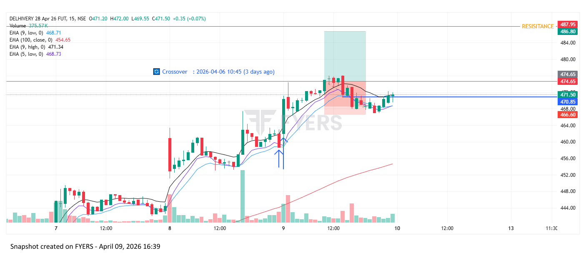
🟢 BULLISH SIGNAL --- HINDALCO26AprFUT

Nifty Bias : 🟢 LONG — Aligned ✅
Crossover : 2026-04-02 13:00 (7 days ago)
Pullback : 2026-04-08 15:00
Low ₹955.1 ≤ EMA9(Low) ₹955.53
High ₹957.8 (breakout level)
Confirm : 2026-04-09 09:15 (+2 candle)
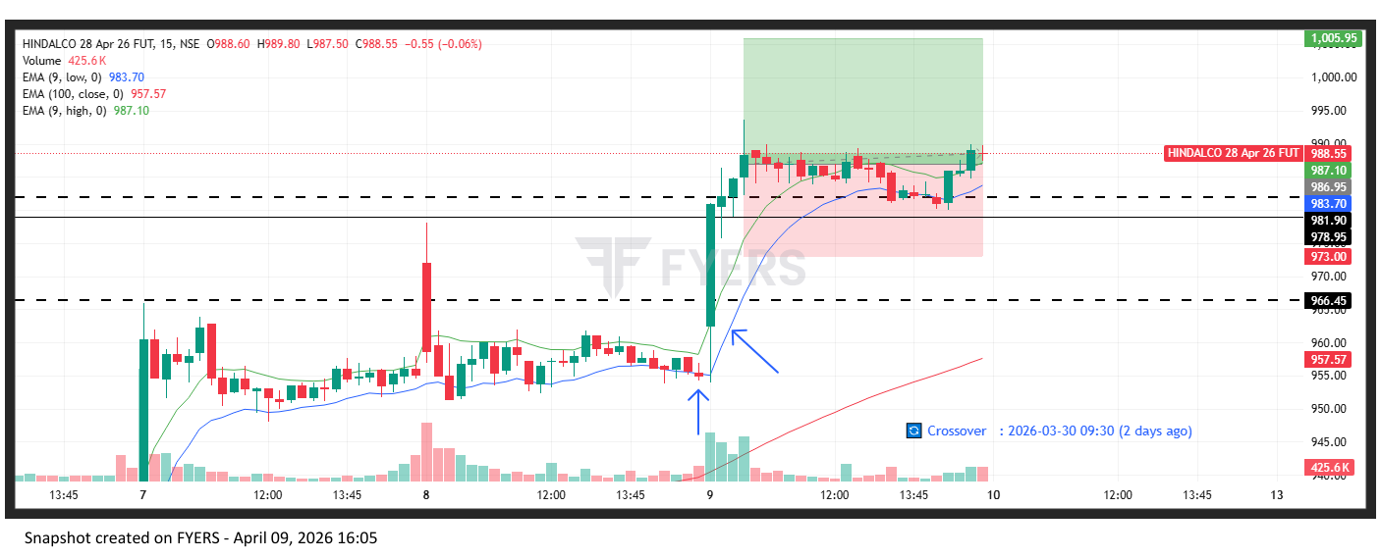
🟢 BULLISH SIGNAL --- MAZDOCK26AprFUT

Nifty Bias : 🟢 LONG — Aligned ✅
Crossover : 2026-04-06 10:00 (3 days ago)
Pullback : 2026-04-08 15:00
Low ₹2399.8 ≤ EMA9(Low) ₹2399.84
High ₹2406.8 (breakout level)
Confirm : 2026-04-09 09:15 (+2 candle)
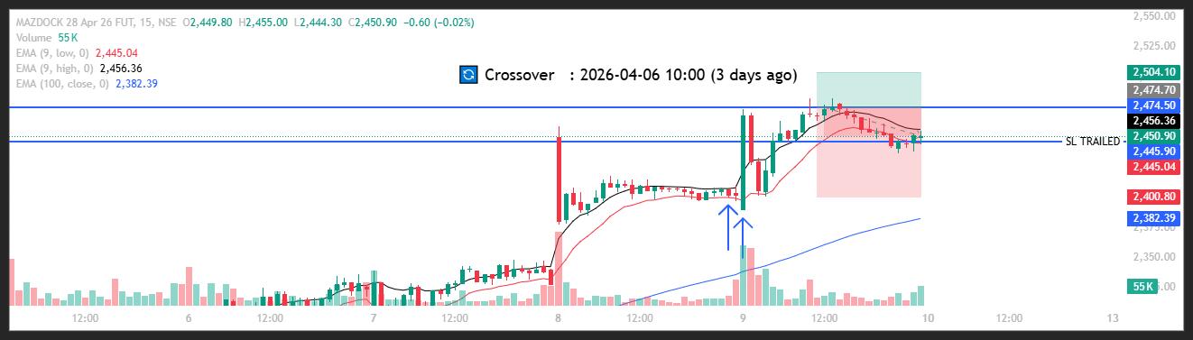
🟢 BULLISH SIGNAL --- PAGEIND26AprFUT

Nifty Bias : 🟢 LONG — Aligned ✅
Crossover : 2026-04-01 10:15 (8 days ago)
Pullback : 2026-04-08 14:45
Low ₹35405 ≤ EMA9(Low) ₹35472.09
High ₹35650 (breakout level)
Confirm : 2026-04-09 09:15 (+3 candle)
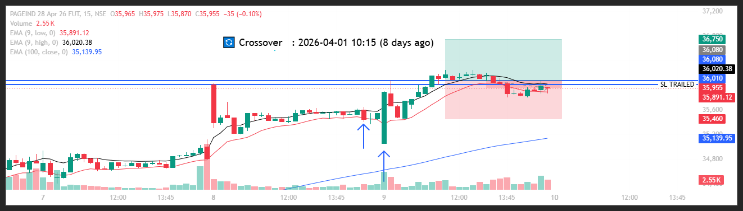
🟢 BULLISH SIGNAL --- BHEL26AprFUT

Nifty Bias : 🟢 LONG — Aligned ✅
Crossover : 2026-04-07 13:45 (2 days ago)
Pullback : 2026-04-09 09:15
Low ₹264.64 ≤ EMA9(Low) ₹265.97
High ₹275.24 (breakout level)
Confirm : 2026-04-09 09:30 (+1 candle)
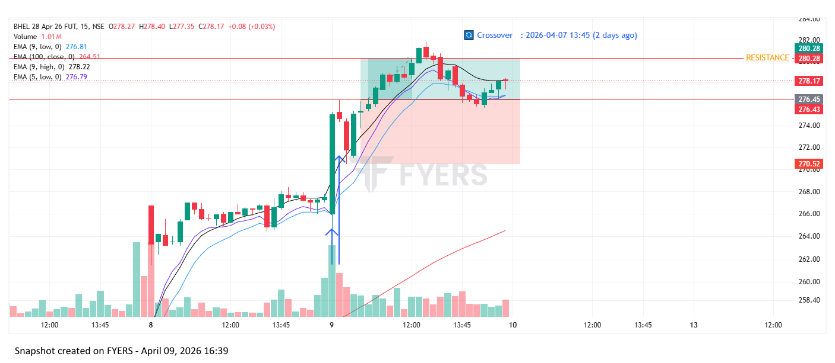
🟢 BULLISH SIGNAL --- BOSCHLTD26AprFUT

Nifty Bias : 🔴 SHORT — Counter Trend ⚠️
Crossover : 2026-04-01 10:30 (8 days ago)
Pullback : 2026-04-09 09:30
Low ₹35900 ≤ EMA9(Low) ₹35980.43
High ₹36340 (breakout level)
Confirm : 2026-04-09 09:45 (+1 candle)
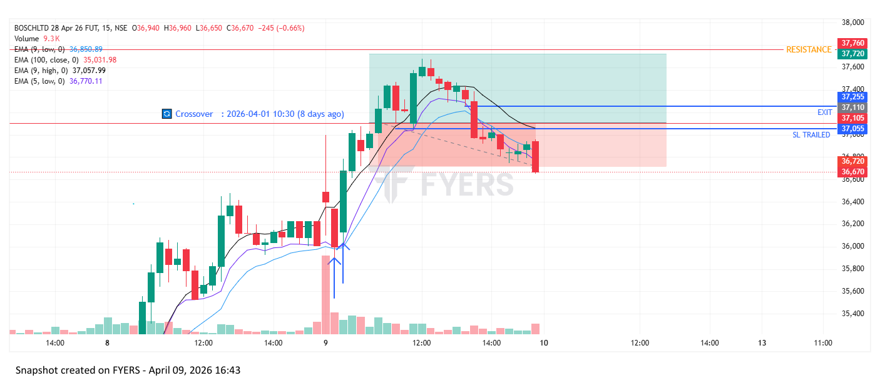
🟢 BULLISH SIGNAL --- ICICIPRULI26AprFUT

Nifty Bias : 🔴 SHORT — Counter Trend ⚠️
Crossover : 2026-04-07 13:45 (2 days ago)
Pullback : 2026-04-09 09:15
Low ₹538 ≤ EMA9(Low) ₹540.8
High ₹548.45 (breakout level)
Confirm : 2026-04-09 09:45 (+2 candle)
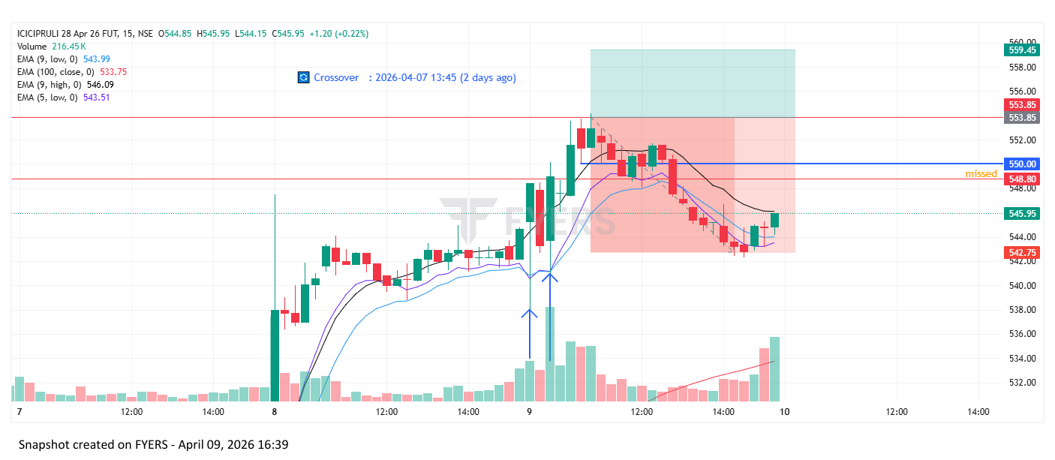
🟢 BULLISH SIGNAL --- ONGC26AprFUT

Nifty Bias : 🔴 SHORT — Counter Trend ⚠️
Crossover : 2026-04-08 13:45 (20 hours ago)
Pullback : 2026-04-09 09:15
Low ₹285.7 ≤ EMA9(Low) ₹285.89
High ₹288.6 (breakout level)
Confirm : 2026-04-09 09:45 (+2 candle)
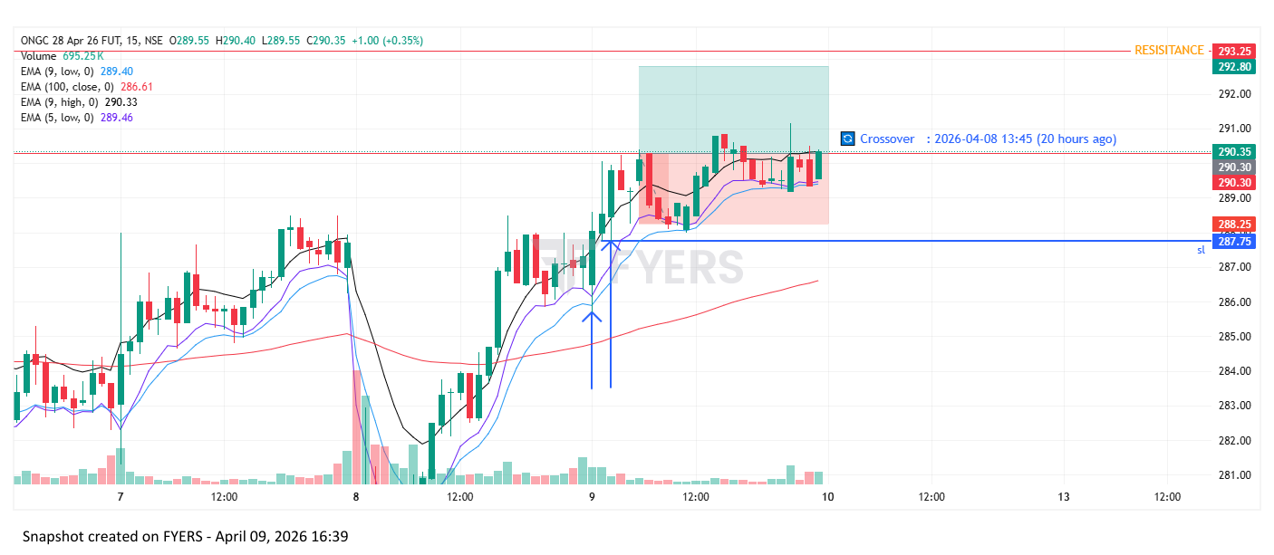
🟢 BULLISH SIGNAL --- POWERINDIA26AprFUT

Nifty Bias : 🔴 SHORT — Counter Trend ⚠️
Crossover : 2026-04-08 09:15 (a day ago)
Pullback : 2026-04-09 09:45
Low ₹25925 ≤ EMA9(Low) ₹25988.01
High ₹26230 (breakout level)
Confirm : 2026-04-09 10:00 (+1 candle)
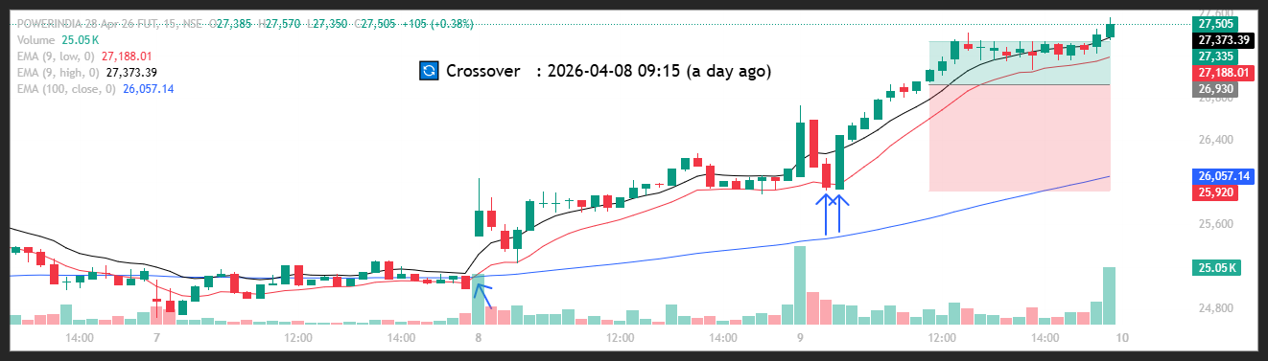
🟢 BULLISH SIGNAL --- KALYANKJIL26AprFUT

Nifty Bias : 🔴 SHORT — Counter Trend ⚠️
Crossover : 2026-04-02 14:30 (7 days ago)
Pullback : 2026-04-09 09:45
Low ₹441.9 ≤ EMA9(Low) ₹443.26
High ₹444.15 (breakout level)
Confirm : 2026-04-09 10:00 (+1 candle)
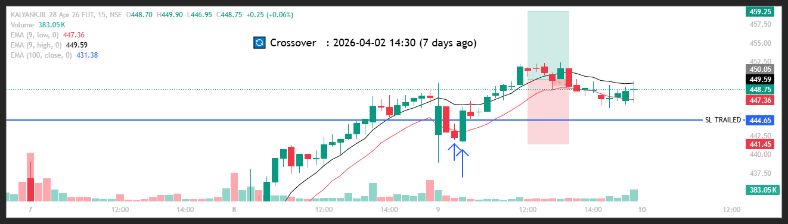
🟢 BULLISH SIGNAL --- BLUESTARCO26AprFUT

Nifty Bias : 🔴 SHORT — Counter Trend ⚠️
Crossover : 2026-04-08 09:45 (a day ago)
Pullback : 2026-04-09 09:45
Low ₹1603.5 ≤ EMA9(Low) ₹1610.99
High ₹1621 (breakout level)
Confirm : 2026-04-09 10:15 (+2 candle)
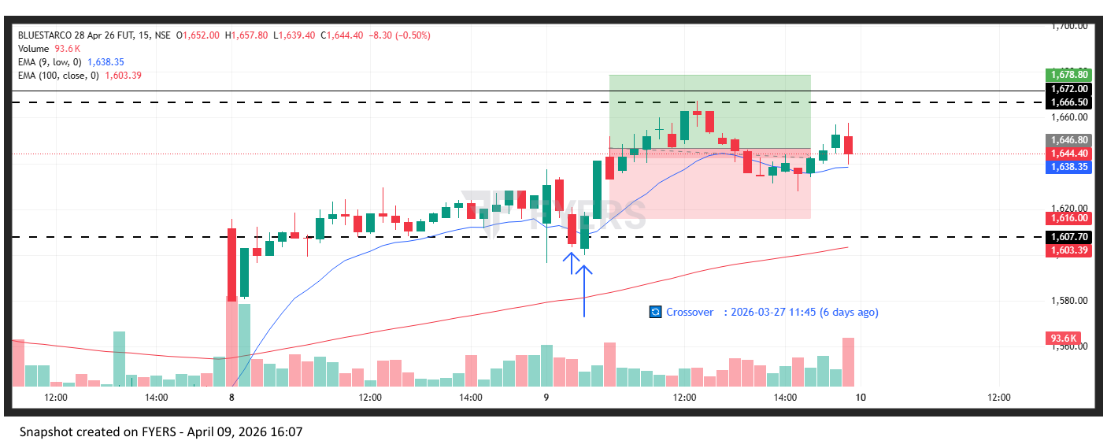
🟢 BULLISH SIGNAL --- LODHA26AprFUT

Nifty Bias : 🔴 SHORT — Counter Trend ⚠️
Crossover : 2026-04-06 10:15 (3 days ago)
Pullback : 2026-04-09 09:45
Low ₹765.15 ≤ EMA9(Low) ₹773.05
High ₹776.5 (breakout level)
Confirm : 2026-04-09 10:30 (+3 candle)
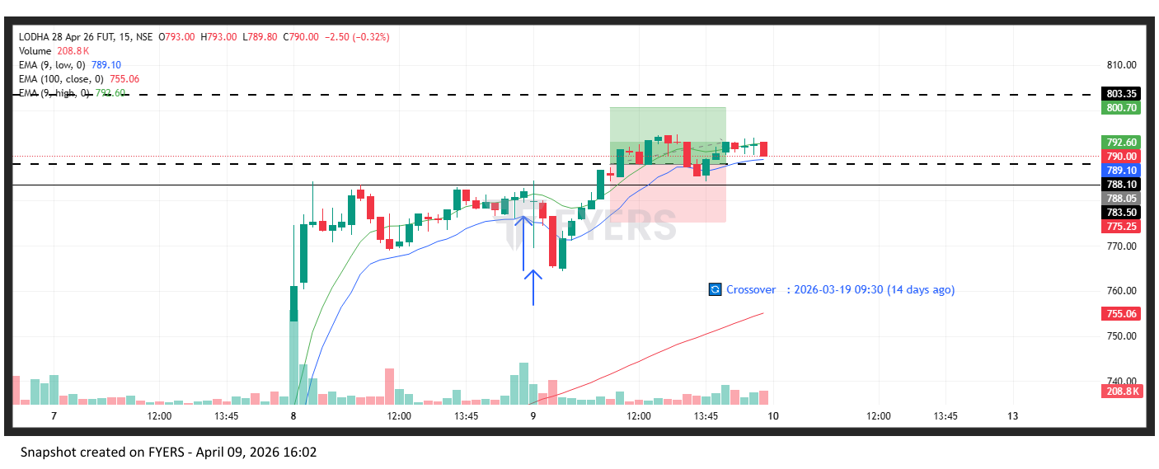
🟢 BULLISH SIGNAL --- PAYTM26AprFUT

Nifty Bias : 🔴 SHORT — Counter Trend ⚠️
Crossover : 2026-04-06 13:00 (3 days ago)
Pullback : 2026-04-09 09:45
Low ₹1105.6 ≤ EMA9(Low) ₹1107.41
High ₹1115.85 (breakout level)
Confirm : 2026-04-09 10:15 (+2 candle)
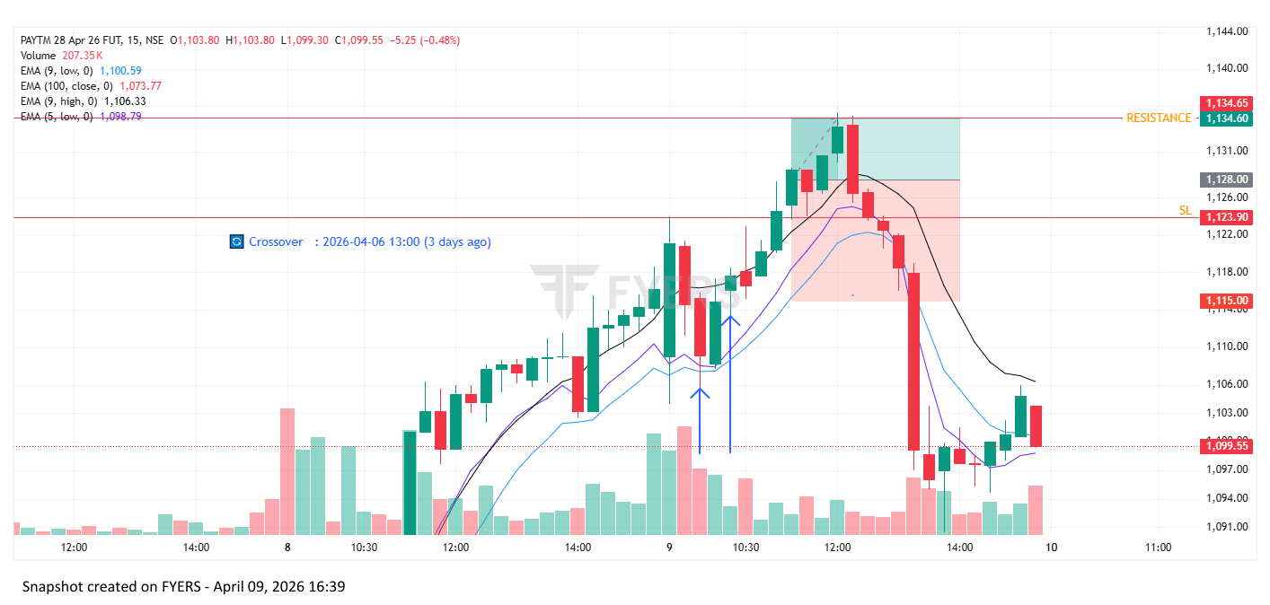

Trade Not Taken
🟢 BULLISH SIGNAL --- BSE26AprFUT

Nifty Bias : 🟢 LONG — Aligned ✅
Crossover : 2026-04-02 14:00 (7 days ago)
Pullback : 2026-04-08 15:15
Low ₹3171.5 ≤ EMA9(Low) ₹3171.81
High ₹3185 (breakout level)
Confirm : 2026-04-09 09:15 (+1 candle)
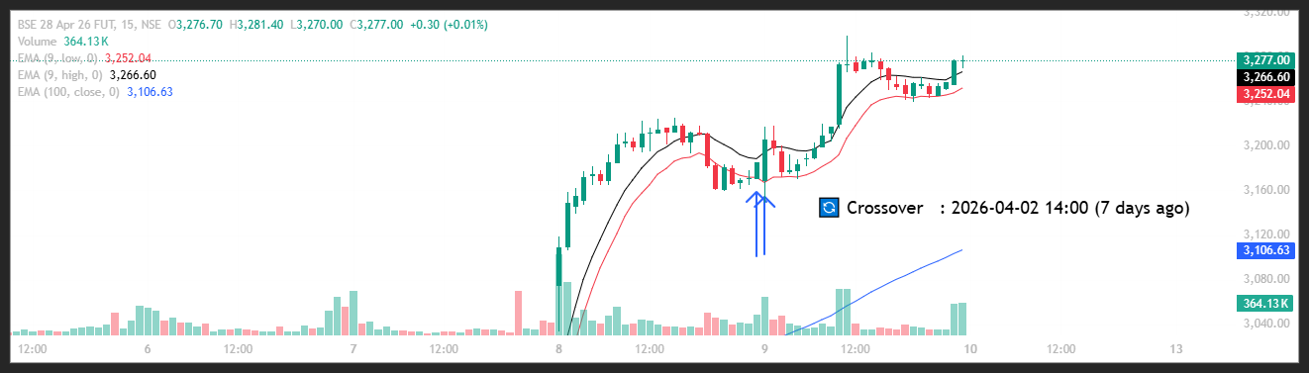
🟢 BULLISH SIGNAL --- BAJAJ-AUTO26AprFUT

Nifty Bias : 🟢 LONG — Aligned ✅
Crossover : 2026-04-06 11:15 (3 days ago)
Pullback : 2026-04-08 14:45
Low ₹9369 ≤ EMA9(Low) ₹9379.66
High ₹9396.5 (breakout level)
Confirm : 2026-04-09 09:15 (+3 candle)
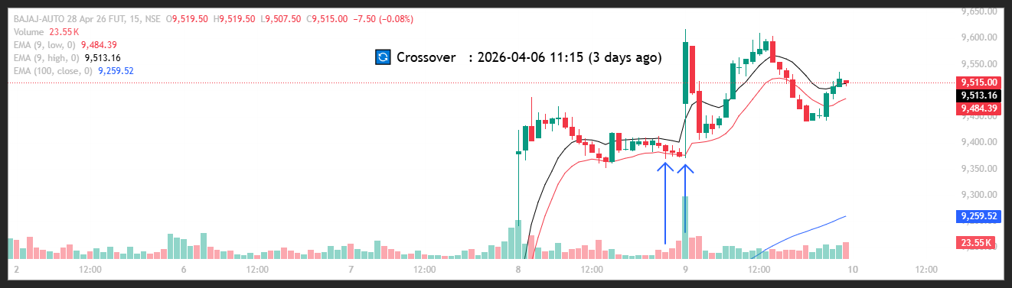
🟢 BULLISH SIGNAL --- CGPOWER26AprFUT

Nifty Bias : 🟢 LONG — Aligned ✅
Crossover : 2026-04-02 15:00 (7 days ago)
Pullback : 2026-04-08 15:00
Low ₹725.9 ≤ EMA9(Low) ₹726.16
High ₹728.9 (breakout level)
Confirm : 2026-04-09 09:15 (+2 candle)
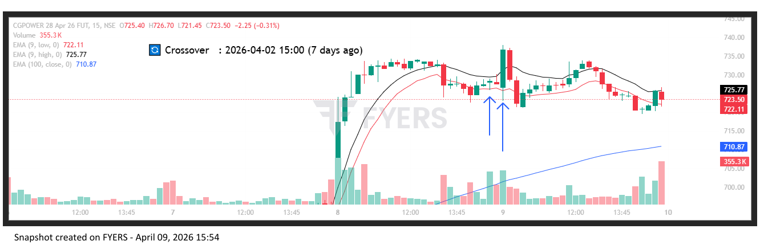
🟢 BULLISH SIGNAL --- CROMPTON26AprFUT

Nifty Bias : 🟢 LONG — Aligned ✅
Crossover : 2026-04-06 12:15 (3 days ago)
Pullback : 2026-04-08 15:00
Low ₹246.86 ≤ EMA9(Low) ₹247.45
High ₹247.73 (breakout level)
Confirm : 2026-04-09 09:15 (+2 candle)
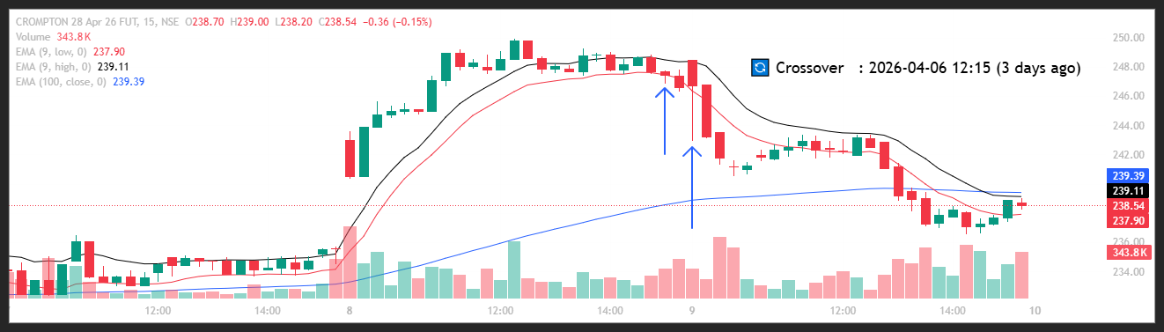
🔴 BEARISH SIGNAL --- DRREDDY26AprFUT

Nifty Bias : 🟢 LONG — Counter Trend ⚠️
Crossover : 2026-03-30 09:30 (10 days ago)
Pullback : 2026-04-08 14:45
High ₹1190.9 ≥ EMA9(High) ₹1190.81
Low ₹1189 (breakdown level)
Confirm : 2026-04-09 09:15 (+3 candle)
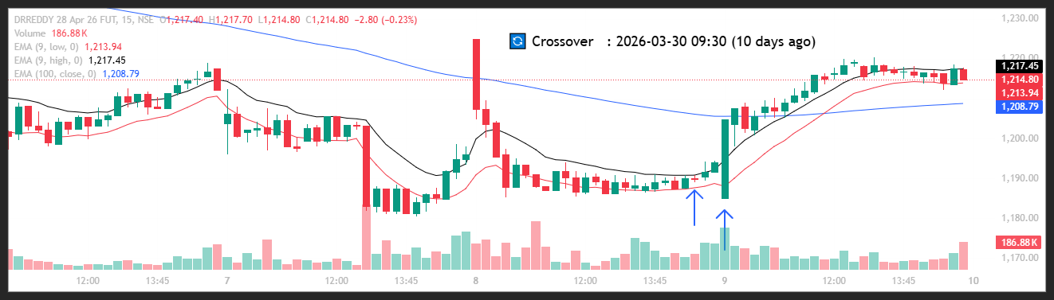
🟢 BULLISH SIGNAL --- EXIDEIND26AprFUT

Nifty Bias : 🟢 LONG — Aligned ✅
Crossover : 2026-04-08 09:15 (a day ago)
Pullback : 2026-04-08 15:00
Low ₹315.2 ≤ EMA9(Low) ₹315.86
High ₹316.5 (breakout level)
Confirm : 2026-04-09 09:15 (+2 candle)
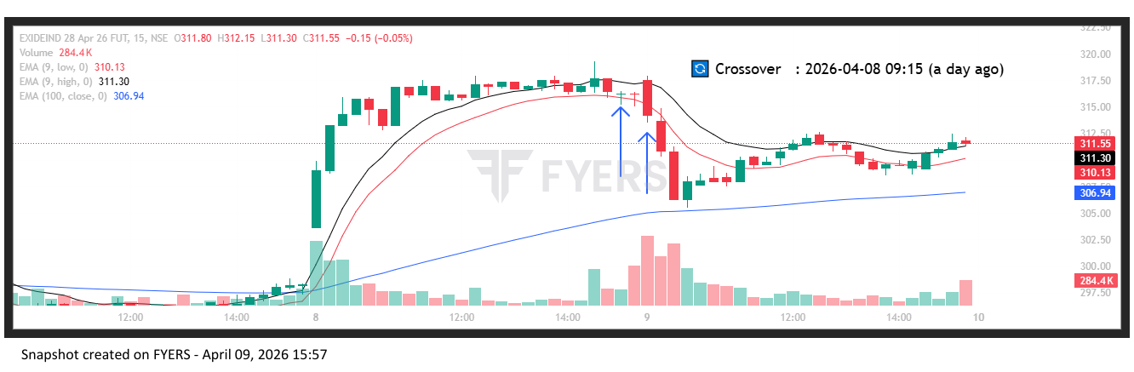
🟢 BULLISH SIGNAL --- GAIL26AprFUT

Nifty Bias : 🟢 LONG — Aligned ✅
Crossover : 2026-04-02 14:15 (7 days ago)
Pullback : 2026-04-08 14:45
Low ₹153.28 ≤ EMA9(Low) ₹153.32
High ₹153.68 (breakout level)
Confirm : 2026-04-09 09:15 (+3 candle)
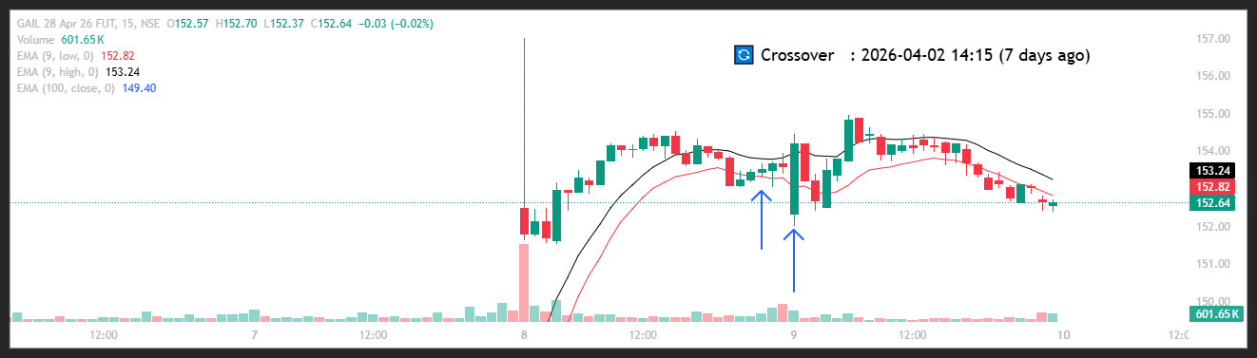
🟢 BULLISH SIGNAL --- HEROMOTOCO26AprFUT

Nifty Bias : 🟢 LONG — Aligned ✅
Crossover : 2026-04-08 09:15 (a day ago)
Pullback : 2026-04-08 14:45
Low ₹5315 ≤ EMA9(Low) ₹5318.15
High ₹5337.5 (breakout level)
Confirm : 2026-04-09 09:15 (+3 candle)
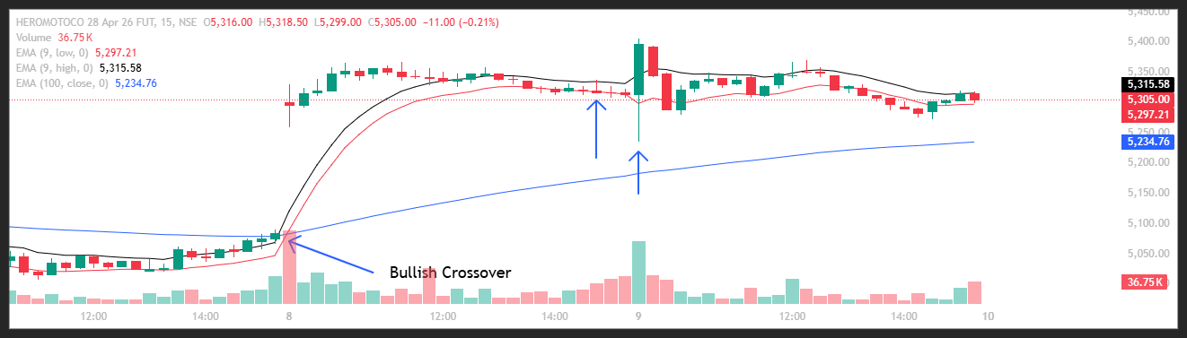
🟢 BULLISH SIGNAL --- HINDUNILVR26AprFUT

Nifty Bias : 🟢 LONG — Aligned ✅
Crossover : 2026-04-07 14:30 (2 days ago)
Pullback : 2026-04-08 15:00
Low ₹2154 ≤ EMA9(Low) ₹2160.38
High ₹2163.7 (breakout level)
Confirm : 2026-04-09 09:15 (+2 candle)
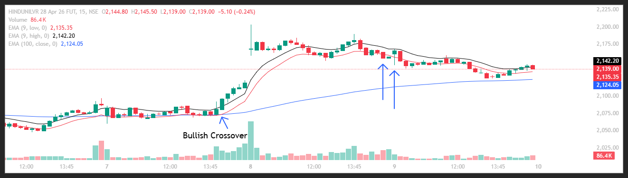
🟢 BULLISH SIGNAL --- HINDZINC26AprFUT

Nifty Bias : 🟢 LONG — Aligned ✅
Crossover : 2026-04-06 09:30 (3 days ago)
Pullback : 2026-04-08 15:15
Low ₹558.55 ≤ EMA9(Low) ₹560.04
High ₹560.6 (breakout level)
Confirm : 2026-04-09 09:15 (+1 candle)
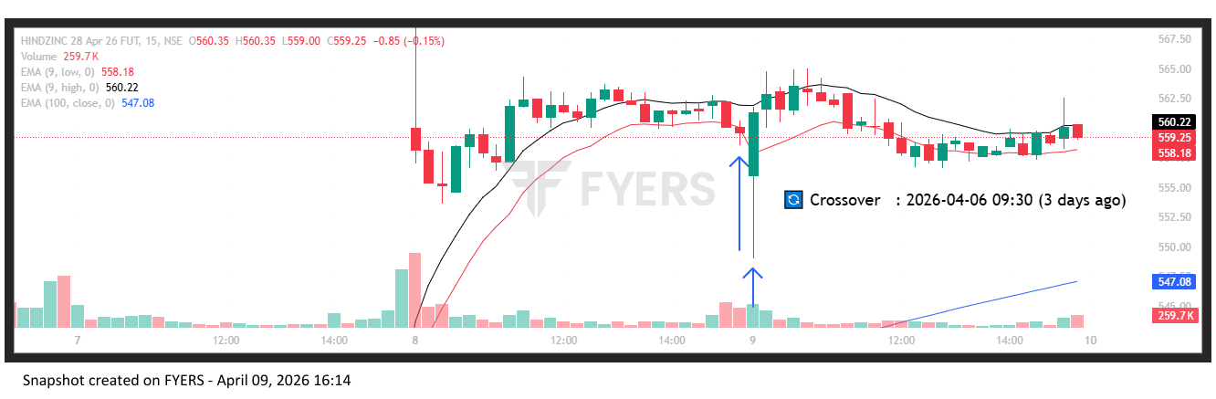
🟢 BULLISH SIGNAL --- ITC26AprFUT

Nifty Bias : 🟢 LONG — Aligned ✅
Crossover : 2026-04-06 13:30 (3 days ago)
Pullback : 2026-04-08 15:00
Low ₹303.2 ≤ EMA9(Low) ₹303.85
High ₹304.45 (breakout level)
Confirm : 2026-04-09 09:15 (+2 candle)
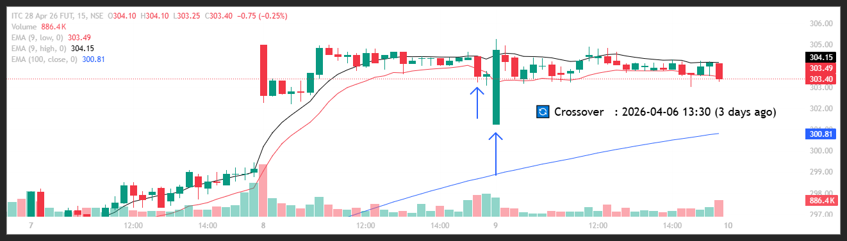
🟢 BULLISH SIGNAL --- JINDALSTEL26AprFUT

Nifty Bias : 🟢 LONG — Aligned ✅
Crossover : 2026-04-07 10:45 (2 days ago)
Pullback : 2026-04-08 15:00
Low ₹1205.4 ≤ EMA9(Low) ₹1206.99
High ₹1211.5 (breakout level)
Confirm : 2026-04-09 09:15 (+2 candle)
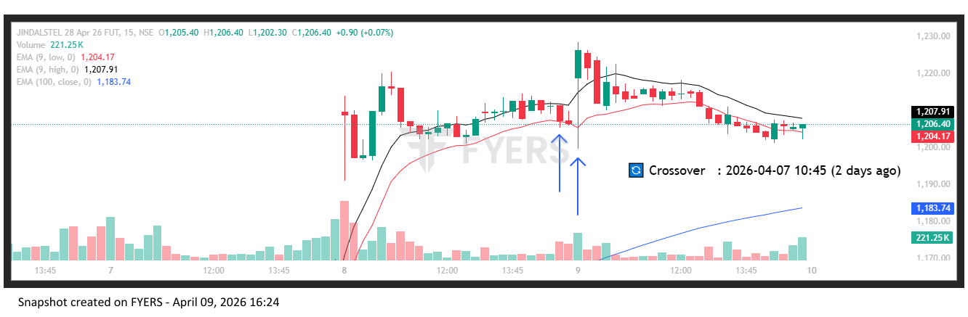
🟢 BULLISH SIGNAL --- KEI26AprFUT

Nifty Bias : 🟢 LONG — Aligned ✅
Crossover : 2026-04-06 10:30 (3 days ago)
Pullback : 2026-04-08 14:45
Low ₹4425.9 ≤ EMA9(Low) ₹4439.75
High ₹4458.1 (breakout level)
Confirm : 2026-04-09 09:15 (+3 candle)
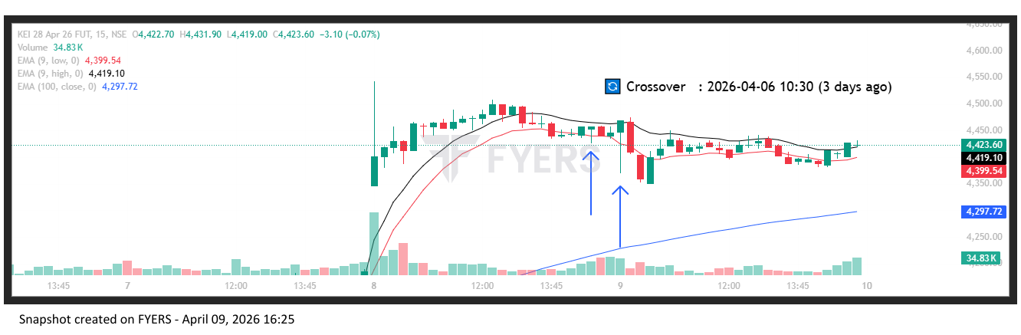
🟢 BULLISH SIGNAL --- MANKIND26AprFUT

Nifty Bias : 🟢 LONG — Aligned ✅
Crossover : 2026-04-06 14:15 (3 days ago)
Pullback : 2026-04-08 15:00
Low ₹2037.7 ≤ EMA9(Low) ₹2043.28
High ₹2049.6 (breakout level)
Confirm : 2026-04-09 09:15 (+2 candle)
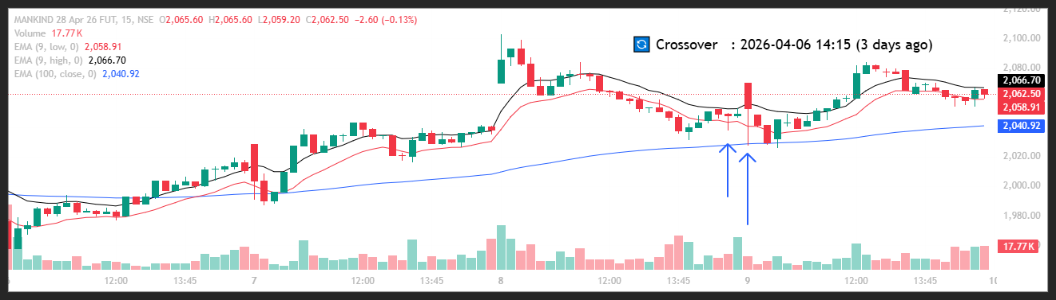
🟢 BULLISH SIGNAL --- MAXHEALTH26AprFUT

Nifty Bias : 🟢 LONG — Aligned ✅
Crossover : 2026-04-08 10:15 (a day ago)
Pullback : 2026-04-08 14:45
Low ₹945.2 ≤ EMA9(Low) ₹946.48
High ₹947.6 (breakout level)
Confirm : 2026-04-09 09:15 (+3 candle)
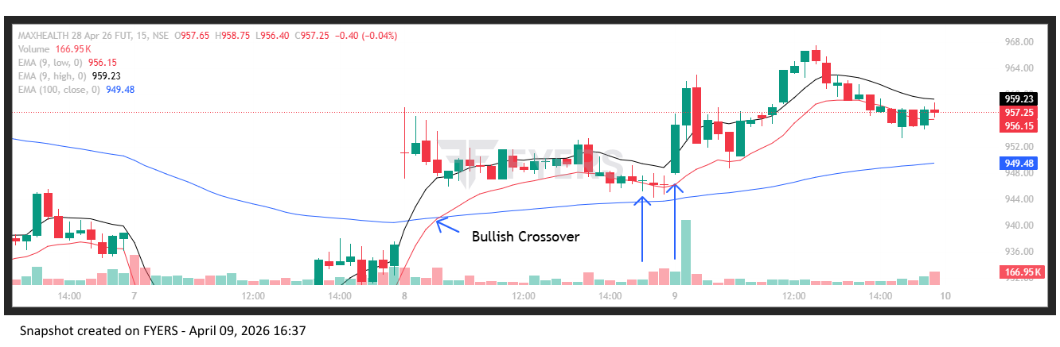
🟢 BULLISH SIGNAL --- NMDC26AprFUT

Nifty Bias : 🟢 LONG — Aligned ✅
Crossover : 2026-04-06 09:30 (3 days ago)
Pullback : 2026-04-08 14:45
Low ₹83.36 ≤ EMA9(Low) ₹83.44
High ₹83.64 (breakout level)
Confirm : 2026-04-09 09:15 (+3 candle)
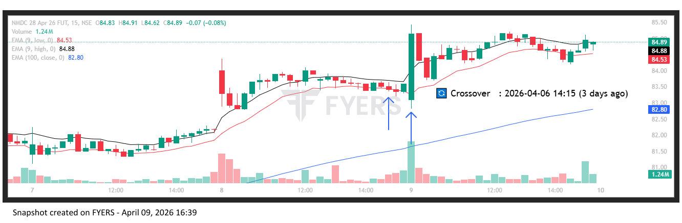
🟢 BULLISH SIGNAL --- NESTLEIND26AprFUT

Nifty Bias : 🟢 LONG — Aligned ✅
Crossover : 2026-04-06 12:30 (3 days ago)
Pullback : 2026-04-08 14:45
Low ₹1214.5 ≤ EMA9(Low) ₹1215.61
High ₹1218.5 (breakout level)
Confirm : 2026-04-09 09:15 (+3 candle)
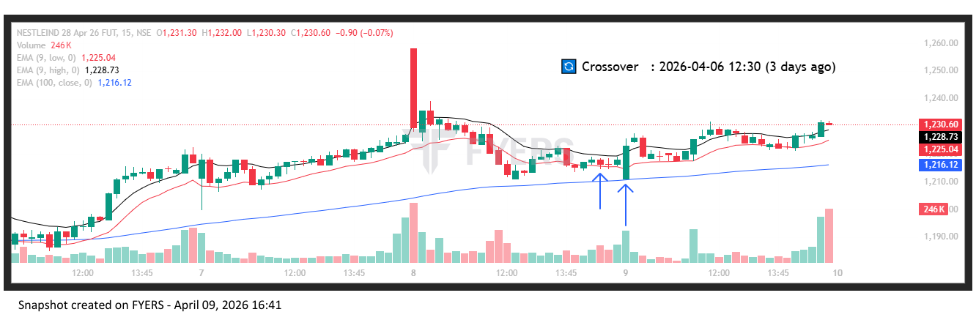
🟢 BULLISH SIGNAL --- OBEROIRLTY26AprFUT

Nifty Bias : 🟢 LONG — Aligned ✅
Crossover : 2026-04-02 12:15 (7 days ago)
Pullback : 2026-04-08 14:45
Low ₹1611.1 ≤ EMA9(Low) ₹1613.31
High ₹1616.3 (breakout level)
Confirm : 2026-04-09 09:15 (+3 candle)

🟢 BULLISH SIGNAL --- OFSS26AprFUT

Nifty Bias : 🟢 LONG — Aligned ✅
Crossover : 2026-04-02 11:00 (7 days ago)
Pullback : 2026-04-08 14:45
Low ₹7123 ≤ EMA9(Low) ₹7171.23
High ₹7188.5 (breakout level)
Confirm : 2026-04-09 09:15 (+3 candle)

🟢 BULLISH SIGNAL --- PIIND26AprFUT

Nifty Bias : 🟢 LONG — Aligned ✅
Crossover : 2026-04-06 13:15 (3 days ago)
Pullback : 2026-04-08 14:45
Low ₹2878.9 ≤ EMA9(Low) ₹2893.67
High ₹2889.8 (breakout level)
Confirm : 2026-04-09 09:15 (+3 candle)

🟢 BULLISH SIGNAL --- PFC26AprFUT

Nifty Bias : 🟢 LONG — Aligned ✅
Crossover : 2026-04-02 14:15 (7 days ago)
Pullback : 2026-04-08 15:00
Low ₹418.2 ≤ EMA9(Low) ₹418.24
High ₹421.1 (breakout level)
Confirm : 2026-04-09 09:15 (+2 candle)

🟢 BULLISH SIGNAL --- SBILIFE26AprFUT

Nifty Bias : 🟢 LONG — Aligned ✅
Crossover : 2026-04-06 13:00 (3 days ago)
Pullback : 2026-04-08 14:45
Low ₹1916.2 ≤ EMA9(Low) ₹1918.27
High ₹1921.7 (breakout level)
Confirm : 2026-04-09 09:15 (+3 candle)

🟢 BULLISH SIGNAL --- SAIL26AprFUT

Nifty Bias : 🟢 LONG — Aligned ✅
Crossover : 2026-04-02 13:30 (7 days ago)
Pullback : 2026-04-08 15:00
Low ₹165.22 ≤ EMA9(Low) ₹165.43
High ₹166.1 (breakout level)
Confirm : 2026-04-09 09:15 (+2 candle)

🟢 BULLISH SIGNAL --- TATACONSUM26AprFUT

Nifty Bias : 🟢 LONG — Aligned ✅
Crossover : 2026-04-06 12:45 (3 days ago)
Pullback : 2026-04-08 15:00
Low ₹1071.9 ≤ EMA9(Low) ₹1072.05
High ₹1075.2 (breakout level)
Confirm : 2026-04-09 09:15 (+2 candle)

🟢 BULLISH SIGNAL --- TATASTEEL26AprFUT

Nifty Bias : 🟢 LONG — Aligned ✅
Crossover : 2026-04-06 11:00 (3 days ago)
Pullback : 2026-04-08 15:00
Low ₹204.91 ≤ EMA9(Low) ₹205.29
High ₹206.06 (breakout level)
Confirm : 2026-04-09 09:15 (+2 candle)

🟢 BULLISH SIGNAL --- PHOENIXLTD26AprFUT

Nifty Bias : 🟢 LONG — Aligned ✅
Crossover : 2026-04-06 10:15 (3 days ago)
Pullback : 2026-04-08 15:00
Low ₹1712.1 ≤ EMA9(Low) ₹1716.75
High ₹1720 (breakout level)
Confirm : 2026-04-09 09:15 (+2 candle)

🔴 BEARISH SIGNAL --- TORNTPHARM26AprFUT

Nifty Bias : 🟢 LONG — Counter Trend ⚠️
Crossover : 2026-04-08 09:45 (a day ago)
Pullback : 2026-04-08 15:15
High ₹4053 ≥ EMA9(High) ₹4051.94
Low ₹4044.3 (breakdown level)
Confirm : 2026-04-09 09:15 (+1 candle)

🟢 BULLISH SIGNAL --- TRENT26AprFUT

Nifty Bias : 🟢 LONG — Aligned ✅
Crossover : 2026-04-02 12:45 (7 days ago)
Pullback : 2026-04-08 14:45
Low ₹3889.4 ≤ EMA9(Low) ₹3898.62
High ₹3905 (breakout level)
Confirm : 2026-04-09 09:15 (+3 candle)

🟢 BULLISH SIGNAL --- TIINDIA26AprFUT

Nifty Bias : 🟢 LONG — Aligned ✅
Crossover : 2026-04-07 13:00 (2 days ago)
Pullback : 2026-04-08 15:00
Low ₹2719 ≤ EMA9(Low) ₹2719.04
High ₹2748.4 (breakout level)
Confirm : 2026-04-09 09:15 (+2 candle)

🟢 BULLISH SIGNAL --- UNOMINDA26AprFUT

Nifty Bias : 🟢 LONG — Aligned ✅
Crossover : 2026-04-08 09:30 (a day ago)
Pullback : 2026-04-08 14:45
Low ₹1096.1 ≤ EMA9(Low) ₹1097.95
High ₹1103.3 (breakout level)
Confirm : 2026-04-09 09:15 (+3 candle)

🟢 BULLISH SIGNAL --- UNITDSPR26AprFUT

Nifty Bias : 🟢 LONG — Aligned ✅
Crossover : 2026-04-08 09:15 (a day ago)
Pullback : 2026-04-08 14:45
Low ₹1253.1 ≤ EMA9(Low) ₹1256.97
High ₹1257 (breakout level)
Confirm : 2026-04-09 09:15 (+3 candle)

🟢 BULLISH SIGNAL --- VEDL26AprFUT

Nifty Bias : 🟢 LONG — Aligned ✅
Crossover : 2026-04-02 13:30 (7 days ago)
Pullback : 2026-04-08 15:15
Low ₹723.5 ≤ EMA9(Low) ₹724.13
High ₹727.4 (breakout level)
Confirm : 2026-04-09 09:15 (+1 candle)

🟢 BULLISH SIGNAL --- VOLTAS26AprFUT

Nifty Bias : 🟢 LONG — Aligned ✅
Crossover : 2026-04-08 10:00 (a day ago)
Pullback : 2026-04-08 14:45
Low ₹1255.5 ≤ EMA9(Low) ₹1260.61
High ₹1261.3 (breakout level)
Confirm : 2026-04-09 09:15 (+3 candle)

🟢 BULLISH SIGNAL --- ALKEM26AprFUT

Nifty Bias : 🟢 LONG — Aligned ✅
Crossover : 2026-04-08 11:15 (a day ago)
Pullback : 2026-04-09 09:15
Low ₹5186 ≤ EMA9(Low) ₹5244.79
High ₹5269 (breakout level)
Confirm : 2026-04-09 09:30 (+1 candle)

🟢 BULLISH SIGNAL --- AXISBANK26AprFUT

Nifty Bias : 🟢 LONG — Aligned ✅
Crossover : 2026-04-06 09:15 (3 days ago)
Pullback : 2026-04-09 09:15
Low ₹1320.4 ≤ EMA9(Low) ₹1326.35
High ₹1328 (breakout level)
Confirm : 2026-04-09 09:30 (+1 candle)

🟢 BULLISH SIGNAL --- DALBHARAT26AprFUT

Nifty Bias : 🟢 LONG — Aligned ✅
Crossover : 2026-04-06 10:15 (3 days ago)
Pullback : 2026-04-08 15:00
Low ₹1923.4 ≤ EMA9(Low) ₹1928.77
High ₹1930.5 (breakout level)
Confirm : 2026-04-09 09:30 (+3 candle)

🟢 BULLISH SIGNAL --- HAL26AprFUT

Nifty Bias : 🟢 LONG — Aligned ✅
Crossover : 2026-04-02 15:15 (7 days ago)
Pullback : 2026-04-09 09:15
Low ₹3895 ≤ EMA9(Low) ₹3902.1
High ₹4012 (breakout level)
Confirm : 2026-04-09 09:30 (+1 candle)

🟢 BULLISH SIGNAL --- POWERGRID26AprFUT

Nifty Bias : 🟢 LONG — Aligned ✅
Crossover : 2026-04-06 14:45 (3 days ago)
Pullback : 2026-04-09 09:15
Low ₹294.9 ≤ EMA9(Low) ₹295.08
High ₹298.6 (breakout level)
Confirm : 2026-04-09 09:30 (+1 candle)

🟢 BULLISH SIGNAL --- SUPREMEIND26AprFUT

Nifty Bias : 🟢 LONG — Aligned ✅
Crossover : 2026-04-06 13:30 (3 days ago)
Pullback : 2026-04-09 09:15
Low ₹3714.6 ≤ EMA9(Low) ₹3773.99
High ₹3813.2 (breakout level)
Confirm : 2026-04-09 09:30 (+1 candle)

🟢 BULLISH SIGNAL --- ULTRACEMCO26AprFUT

Nifty Bias : 🟢 LONG — Aligned ✅
Crossover : 2026-04-06 13:30 (3 days ago)
Pullback : 2026-04-09 09:15
Low ₹11453 ≤ EMA9(Low) ₹11619.33
High ₹11558 (breakout level)
Confirm : 2026-04-09 09:30 (+1 candle)

🟢 BULLISH SIGNAL --- ZYDUSLIFE26AprFUT

Nifty Bias : 🟢 LONG — Aligned ✅
Crossover : 2026-04-07 11:30 (2 days ago)
Pullback : 2026-04-09 09:15
Low ₹885.1 ≤ EMA9(Low) ₹889.17
High ₹896.5 (breakout level)
Confirm : 2026-04-09 09:30 (+1 candle)

🟢 BULLISH SIGNAL --- ICICIGI26AprFUT

Nifty Bias : 🔴 SHORT — Counter Trend ⚠️
Crossover : 2026-04-07 12:15 (2 days ago)
Pullback : 2026-04-09 09:30
Low ₹1744 ≤ EMA9(Low) ₹1752.11
High ₹1752.6 (breakout level)
Confirm : 2026-04-09 09:45 (+1 candle)

🟢 BULLISH SIGNAL --- SHRIRAMFIN26AprFUT

Nifty Bias : 🔴 SHORT — Counter Trend ⚠️
Crossover : 2026-04-06 11:30 (3 days ago)
Pullback : 2026-04-09 09:30
Low ₹1005.55 ≤ EMA9(Low) ₹1016.74
High ₹1012.8 (breakout level)
Confirm : 2026-04-09 09:45 (+1 candle)

🟢 BULLISH SIGNAL --- ADANIENSOL26AprFUT

Nifty Bias : 🔴 SHORT — Counter Trend ⚠️
Crossover : 2026-04-06 10:45 (3 days ago)
Pullback : 2026-04-09 09:30
Low ₹1065.95 ≤ EMA9(Low) ₹1069
High ₹1072.8 (breakout level)
Confirm : 2026-04-09 10:00 (+2 candle)

🟢 BULLISH SIGNAL --- ADANIENT26AprFUT

Nifty Bias : 🔴 SHORT — Counter Trend ⚠️
Crossover : 2026-04-06 12:00 (3 days ago)
Pullback : 2026-04-09 09:45
Low ₹2018.9 ≤ EMA9(Low) ₹2034.66
High ₹2030.8 (breakout level)
Confirm : 2026-04-09 10:00 (+1 candle)

🟢 BULLISH SIGNAL --- ADANIGREEN26AprFUT

Nifty Bias : 🔴 SHORT — Counter Trend ⚠️
Crossover : 2026-04-02 15:15 (7 days ago)
Pullback : 2026-04-09 09:15
Low ₹1025.4 ≤ EMA9(Low) ₹1026.61
High ₹1038.3 (breakout level)
Confirm : 2026-04-09 10:00 (+3 candle)

🟢 BULLISH SIGNAL --- ADANIPORTS26AprFUT

Nifty Bias : 🔴 SHORT — Counter Trend ⚠️
Crossover : 2026-04-06 13:00 (3 days ago)
Pullback : 2026-04-09 09:30
Low ₹1438.5 ≤ EMA9(Low) ₹1447.41
High ₹1446.5 (breakout level)
Confirm : 2026-04-09 10:00 (+2 candle)

🟢 BULLISH SIGNAL --- ABCAPITAL26AprFUT

Nifty Bias : 🔴 SHORT — Counter Trend ⚠️
Crossover : 2026-04-06 10:45 (3 days ago)
Pullback : 2026-04-09 09:15
Low ₹333.3 ≤ EMA9(Low) ₹337.33
High ₹340.15 (breakout level)
Confirm : 2026-04-09 10:00 (+3 candle)

🟢 BULLISH SIGNAL --- APOLLOHOSP26AprFUT

Nifty Bias : 🔴 SHORT — Counter Trend ⚠️
Crossover : 2026-04-08 14:45 (20 hours ago)
Pullback : 2026-04-09 09:15
Low ₹7385 ≤ EMA9(Low) ₹7391.35
High ₹7489 (breakout level)
Confirm : 2026-04-09 10:00 (+3 candle)

🟢 BULLISH SIGNAL --- BANKBARODA26AprFUT

Nifty Bias : 🔴 SHORT — Counter Trend ⚠️
Crossover : 2026-04-06 13:30 (3 days ago)
Pullback : 2026-04-09 09:15
Low ₹273.65 ≤ EMA9(Low) ₹275.61
High ₹277.43 (breakout level)
Confirm : 2026-04-09 10:00 (+3 candle)

🟢 BULLISH SIGNAL --- BANKINDIA26AprFUT

Nifty Bias : 🔴 SHORT — Counter Trend ⚠️
Crossover : 2026-04-08 09:45 (a day ago)
Pullback : 2026-04-09 09:45
Low ₹146.09 ≤ EMA9(Low) ₹146.29
High ₹146.79 (breakout level)
Confirm : 2026-04-09 10:00 (+1 candle)

🟢 BULLISH SIGNAL --- CHOLAFIN26AprFUT

Nifty Bias : 🔴 SHORT — Counter Trend ⚠️
Crossover : 2026-04-06 14:15 (3 days ago)
Pullback : 2026-04-09 09:30
Low ₹1531.1 ≤ EMA9(Low) ₹1543.79
High ₹1539 (breakout level)
Confirm : 2026-04-09 10:00 (+2 candle)

🟢 BULLISH SIGNAL --- CONCOR26AprFUT

Nifty Bias : 🔴 SHORT — Counter Trend ⚠️
Crossover : 2026-04-06 10:15 (3 days ago)
Pullback : 2026-04-09 09:45
Low ₹465.35 ≤ EMA9(Low) ₹470.33
High ₹469.7 (breakout level)
Confirm : 2026-04-09 10:00 (+1 candle)

🟢 BULLISH SIGNAL --- GLENMARK26AprFUT

Nifty Bias : 🔴 SHORT — Counter Trend ⚠️
Crossover : 2026-04-07 10:45 (2 days ago)
Pullback : 2026-04-09 09:30
Low ₹2145.3 ≤ EMA9(Low) ₹2166.92
High ₹2166.4 (breakout level)
Confirm : 2026-04-09 10:00 (+2 candle)

🟢 BULLISH SIGNAL --- HDFCAMC26AprFUT

Nifty Bias : 🔴 SHORT — Counter Trend ⚠️
Crossover : 2026-04-02 13:30 (7 days ago)
Pullback : 2026-04-09 09:45
Low ₹2498.3 ≤ EMA9(Low) ₹2523.37
High ₹2516 (breakout level)
Confirm : 2026-04-09 10:00 (+1 candle)

🟢 BULLISH SIGNAL --- HDFCLIFE26AprFUT

Nifty Bias : 🔴 SHORT — Counter Trend ⚠️
Crossover : 2026-04-08 09:15 (a day ago)
Pullback : 2026-04-09 09:45
Low ₹589.2 ≤ EMA9(Low) ₹597.37
High ₹593.1 (breakout level)
Confirm : 2026-04-09 10:00 (+1 candle)

🟢 BULLISH SIGNAL --- HINDPETRO26AprFUT

Nifty Bias : 🔴 SHORT — Counter Trend ⚠️
Crossover : 2026-04-08 09:15 (a day ago)
Pullback : 2026-04-09 09:45
Low ₹357.1 ≤ EMA9(Low) ₹360.14
High ₹359.3 (breakout level)
Confirm : 2026-04-09 10:00 (+1 candle)

🟢 BULLISH SIGNAL --- IDFCFIRSTB26AprFUT

Nifty Bias : 🔴 SHORT — Counter Trend ⚠️
Crossover : 2026-04-06 14:45 (3 days ago)
Pullback : 2026-04-09 09:45
Low ₹65.59 ≤ EMA9(Low) ₹65.63
High ₹65.94 (breakout level)
Confirm : 2026-04-09 10:00 (+1 candle)

🟢 BULLISH SIGNAL --- INDIANB26AprFUT

Nifty Bias : 🔴 SHORT — Counter Trend ⚠️
Crossover : 2026-04-06 09:30 (3 days ago)
Pullback : 2026-04-09 09:45
Low ₹954.7 ≤ EMA9(Low) ₹955.46
High ₹959.6 (breakout level)
Confirm : 2026-04-09 10:00 (+1 candle)

🟢 BULLISH SIGNAL --- IREDA26AprFUT

Nifty Bias : 🔴 SHORT — Counter Trend ⚠️
Crossover : 2026-04-06 10:45 (3 days ago)
Pullback : 2026-04-09 09:45
Low ₹120.16 ≤ EMA9(Low) ₹121.2
High ₹121 (breakout level)
Confirm : 2026-04-09 10:00 (+1 candle)

🟢 BULLISH SIGNAL --- LTF26AprFUT

Nifty Bias : 🔴 SHORT — Counter Trend ⚠️
Crossover : 2026-04-06 10:45 (3 days ago)
Pullback : 2026-04-09 09:45
Low ₹272.77 ≤ EMA9(Low) ₹274.32
High ₹274.35 (breakout level)
Confirm : 2026-04-09 10:00 (+1 candle)

🟢 BULLISH SIGNAL --- SONACOMS26AprFUT

Nifty Bias : 🔴 SHORT — Counter Trend ⚠️
Crossover : 2026-04-06 09:45 (3 days ago)
Pullback : 2026-04-09 09:45
Low ₹527.6 ≤ EMA9(Low) ₹531.85
High ₹531.45 (breakout level)
Confirm : 2026-04-09 10:00 (+1 candle)

🟢 BULLISH SIGNAL --- SBIN26AprFUT

Nifty Bias : 🔴 SHORT — Counter Trend ⚠️
Crossover : 2026-04-06 12:45 (3 days ago)
Pullback : 2026-04-09 09:45
Low ₹1056 ≤ EMA9(Low) ₹1062.77
High ₹1059.5 (breakout level)
Confirm : 2026-04-09 10:00 (+1 candle)

🟢 BULLISH SIGNAL --- TATAPOWER26AprFUT

Nifty Bias : 🔴 SHORT — Counter Trend ⚠️
Crossover : 2026-04-06 14:00 (3 days ago)
Pullback : 2026-04-09 09:45
Low ₹394.25 ≤ EMA9(Low) ₹395.3
High ₹396.35 (breakout level)
Confirm : 2026-04-09 10:00 (+1 candle)

🟢 BULLISH SIGNAL --- TORNTPOWER26AprFUT

Nifty Bias : 🔴 SHORT — Counter Trend ⚠️
Crossover : 2026-04-06 10:15 (3 days ago)
Pullback : 2026-04-09 09:45
Low ₹1440 ≤ EMA9(Low) ₹1445.75
High ₹1448.6 (breakout level)
Confirm : 2026-04-09 10:00 (+1 candle)

🟢 BULLISH SIGNAL --- UNIONBANK26AprFUT

Nifty Bias : 🔴 SHORT — Counter Trend ⚠️
Crossover : 2026-04-08 09:15 (a day ago)
Pullback : 2026-04-09 09:45
Low ₹184.56 ≤ EMA9(Low) ₹184.86
High ₹185.53 (breakout level)
Confirm : 2026-04-09 10:00 (+1 candle)

🟢 BULLISH SIGNAL --- VBL26AprFUT

Nifty Bias : 🔴 SHORT — Counter Trend ⚠️
Crossover : 2026-04-07 12:45 (2 days ago)
Pullback : 2026-04-09 09:45
Low ₹416.95 ≤ EMA9(Low) ₹419.43
High ₹419.85 (breakout level)
Confirm : 2026-04-09 10:00 (+1 candle)

🟢 BULLISH SIGNAL --- ABB26AprFUT

Nifty Bias : 🔴 SHORT — Counter Trend ⚠️
Crossover : 2026-04-02 14:15 (7 days ago)
Pullback : 2026-04-09 10:00
Low ₹6512 ≤ EMA9(Low) ₹6515.65
High ₹6527 (breakout level)
Confirm : 2026-04-09 10:15 (+1 candle)

🟢 BULLISH SIGNAL --- AUBANK26AprFUT

Nifty Bias : 🔴 SHORT — Counter Trend ⚠️
Crossover : 2026-04-06 12:45 (3 days ago)
Pullback : 2026-04-09 09:45
Low ₹963 ≤ EMA9(Low) ₹964.94
High ₹969.45 (breakout level)
Confirm : 2026-04-09 10:15 (+2 candle)

🟢 BULLISH SIGNAL --- BDL26AprFUT

Nifty Bias : 🔴 SHORT — Counter Trend ⚠️
Crossover : 2026-04-01 10:15 (8 days ago)
Pullback : 2026-04-09 09:45
Low ₹1281 ≤ EMA9(Low) ₹1282.44
High ₹1295.8 (breakout level)
Confirm : 2026-04-09 10:15 (+2 candle)

🟢 BULLISH SIGNAL --- BHARATFORG26AprFUT

Nifty Bias : 🔴 SHORT — Counter Trend ⚠️
Crossover : 2026-04-07 15:15 (2 days ago)
Pullback : 2026-04-09 09:45
Low ₹1747.2 ≤ EMA9(Low) ₹1770.6
High ₹1763.9 (breakout level)
Confirm : 2026-04-09 10:15 (+2 candle)

🟢 BULLISH SIGNAL --- BRITANNIA26AprFUT

Nifty Bias : 🔴 SHORT — Counter Trend ⚠️
Crossover : 2026-04-07 12:15 (2 days ago)
Pullback : 2026-04-09 10:00
Low ₹5601.5 ≤ EMA9(Low) ₹5608.69
High ₹5627 (breakout level)
Confirm : 2026-04-09 10:15 (+1 candle)

🔴 BEARISH SIGNAL --- COALINDIA26AprFUT

Nifty Bias : 🔴 SHORT — Aligned ✅
Crossover : 2026-04-08 10:15 (a day ago)
Pullback : 2026-04-09 10:00
High ₹454.8 ≥ EMA9(High) ₹450.27
Low ₹451.05 (breakdown level)
Confirm : 2026-04-09 10:15 (+1 candle)

🟢 BULLISH SIGNAL --- COLPAL26AprFUT

Nifty Bias : 🔴 SHORT — Counter Trend ⚠️
Crossover : 2026-04-07 12:30 (2 days ago)
Pullback : 2026-04-09 09:45
Low ₹1899.1 ≤ EMA9(Low) ₹1901.41
High ₹1910.8 (breakout level)
Confirm : 2026-04-09 10:15 (+2 candle)

🟢 BULLISH SIGNAL --- DIXON26AprFUT

Nifty Bias : 🔴 SHORT — Counter Trend ⚠️
Crossover : 2026-04-07 12:00 (2 days ago)
Pullback : 2026-04-09 10:00
Low ₹10385 ≤ EMA9(Low) ₹10517.82
High ₹10476.5 (breakout level)
Confirm : 2026-04-09 10:15 (+1 candle)

🟢 BULLISH SIGNAL --- ETERNAL26AprFUT

Nifty Bias : 🔴 SHORT — Counter Trend ⚠️
Crossover : 2026-04-08 09:15 (a day ago)
Pullback : 2026-04-09 10:00
Low ₹237.5 ≤ EMA9(Low) ₹241.01
High ₹239.45 (breakout level)
Confirm : 2026-04-09 10:15 (+1 candle)

🟢 BULLISH SIGNAL --- EICHERMOT26AprFUT

Nifty Bias : 🔴 SHORT — Counter Trend ⚠️
Crossover : 2026-04-08 09:30 (a day ago)
Pullback : 2026-04-09 10:00
Low ₹7066 ≤ EMA9(Low) ₹7093.86
High ₹7093.5 (breakout level)
Confirm : 2026-04-09 10:15 (+1 candle)

🟢 BULLISH SIGNAL --- ICICIBANK26AprFUT

Nifty Bias : 🔴 SHORT — Counter Trend ⚠️
Crossover : 2026-04-06 13:45 (3 days ago)
Pullback : 2026-04-09 09:45
Low ₹1292.8 ≤ EMA9(Low) ₹1303.47
High ₹1297.8 (breakout level)
Confirm : 2026-04-09 10:15 (+2 candle)

🟢 BULLISH SIGNAL --- IEX26AprFUT

Nifty Bias : 🔴 SHORT — Counter Trend ⚠️
Crossover : 2026-04-06 10:15 (3 days ago)
Pullback : 2026-04-09 09:45
Low ₹127.31 ≤ EMA9(Low) ₹128.7
High ₹128.4 (breakout level)
Confirm : 2026-04-09 10:15 (+2 candle)

🟢 BULLISH SIGNAL --- IRFC26AprFUT

Nifty Bias : 🔴 SHORT — Counter Trend ⚠️
Crossover : 2026-04-06 11:00 (3 days ago)
Pullback : 2026-04-09 09:45
Low ₹97.15 ≤ EMA9(Low) ₹98.03
High ₹98.13 (breakout level)
Confirm : 2026-04-09 10:15 (+2 candle)

🟢 BULLISH SIGNAL --- INDUSINDBK26AprFUT

Nifty Bias : 🔴 SHORT — Counter Trend ⚠️
Crossover : 2026-04-07 13:45 (2 days ago)
Pullback : 2026-04-09 09:45
Low ₹821.75 ≤ EMA9(Low) ₹829.03
High ₹828.45 (breakout level)
Confirm : 2026-04-09 10:15 (+2 candle)

🟢 BULLISH SIGNAL --- INOXWIND26AprFUT

Nifty Bias : 🔴 SHORT — Counter Trend ⚠️
Crossover : 2026-04-06 11:15 (3 days ago)
Pullback : 2026-04-09 09:45
Low ₹84.34 ≤ EMA9(Low) ₹85.8
High ₹85.48 (breakout level)
Confirm : 2026-04-09 10:15 (+2 candle)

🟢 BULLISH SIGNAL --- KPITTECH26AprFUT

Nifty Bias : 🔴 SHORT — Counter Trend ⚠️
Crossover : 2026-04-02 10:45 (7 days ago)
Pullback : 2026-04-09 09:45
Low ₹707.75 ≤ EMA9(Low) ₹715.61
High ₹712.55 (breakout level)
Confirm : 2026-04-09 10:15 (+2 candle)

🟢 BULLISH SIGNAL --- KAYNES26AprFUT

Nifty Bias : 🔴 SHORT — Counter Trend ⚠️
Crossover : 2026-04-06 12:00 (3 days ago)
Pullback : 2026-04-09 10:00
Low ₹3767 ≤ EMA9(Low) ₹3825.43
High ₹3795.7 (breakout level)
Confirm : 2026-04-09 10:15 (+1 candle)

🟢 BULLISH SIGNAL --- LICHSGFIN26AprFUT

Nifty Bias : 🔴 SHORT — Counter Trend ⚠️
Crossover : 2026-04-01 09:15 (8 days ago)
Pullback : 2026-04-09 09:45
Low ₹527.5 ≤ EMA9(Low) ₹528.83
High ₹530.9 (breakout level)
Confirm : 2026-04-09 10:00 (+1 candle)

🟢 BULLISH SIGNAL --- LTM26AprFUT

Nifty Bias : 🔴 SHORT — Counter Trend ⚠️
Crossover : 2026-04-02 12:15 (7 days ago)
Pullback : 2026-04-09 09:45
Low ₹4410 ≤ EMA9(Low) ₹4460.61
High ₹4434.5 (breakout level)
Confirm : 2026-04-09 10:15 (+2 candle)

🟢 BULLISH SIGNAL --- PGEL26AprFUT

Nifty Bias : 🔴 SHORT — Counter Trend ⚠️
Crossover : 2026-04-08 09:45 (a day ago)
Pullback : 2026-04-09 10:00
Low ₹458.5 ≤ EMA9(Low) ₹469.19
High ₹463.95 (breakout level)
Confirm : 2026-04-09 10:15 (+1 candle)

🟢 BULLISH SIGNAL --- PNBHOUSING26AprFUT

Nifty Bias : 🔴 SHORT — Counter Trend ⚠️
Crossover : 2026-04-06 10:15 (3 days ago)
Pullback : 2026-04-09 09:45
Low ₹855.6 ≤ EMA9(Low) ₹868.4
High ₹863.15 (breakout level)
Confirm : 2026-04-09 10:15 (+2 candle)

🟢 BULLISH SIGNAL --- PERSISTENT26AprFUT

Nifty Bias : 🔴 SHORT — Counter Trend ⚠️
Crossover : 2026-04-01 09:45 (8 days ago)
Pullback : 2026-04-09 09:15
Low ₹5272.1 ≤ EMA9(Low) ₹5316.35
High ₹5323.2 (breakout level)
Confirm : 2026-04-09 10:00 (+3 candle)

🟢 BULLISH SIGNAL --- PETRONET26AprFUT

Nifty Bias : 🔴 SHORT — Counter Trend ⚠️
Crossover : 2026-04-07 14:00 (2 days ago)
Pullback : 2026-04-09 09:15
Low ₹261.45 ≤ EMA9(Low) ₹267.72
High ₹267.49 (breakout level)
Confirm : 2026-04-09 10:00 (+3 candle)

🟢 BULLISH SIGNAL --- PRESTIGE26AprFUT

Nifty Bias : 🔴 SHORT — Counter Trend ⚠️
Crossover : 2026-04-06 12:30 (3 days ago)
Pullback : 2026-04-09 09:45
Low ₹1299.4 ≤ EMA9(Low) ₹1314.77
High ₹1313.1 (breakout level)
Confirm : 2026-04-09 10:15 (+2 candle)

🟢 BULLISH SIGNAL --- PNB26AprFUT

Nifty Bias : 🔴 SHORT — Counter Trend ⚠️
Crossover : 2026-04-08 09:15 (a day ago)
Pullback : 2026-04-09 09:30
Low ₹110.66 ≤ EMA9(Low) ₹110.73
High ₹111.04 (breakout level)
Confirm : 2026-04-09 10:00 (+2 candle)

🟢 BULLISH SIGNAL --- RBLBANK26AprFUT

Nifty Bias : 🔴 SHORT — Counter Trend ⚠️
Crossover : 2026-04-02 14:30 (7 days ago)
Pullback : 2026-04-09 09:45
Low ₹315.65 ≤ EMA9(Low) ₹320.09
High ₹318.25 (breakout level)
Confirm : 2026-04-09 10:00 (+1 candle)

🟢 BULLISH SIGNAL --- RECLTD26AprFUT

Nifty Bias : 🔴 SHORT — Counter Trend ⚠️
Crossover : 2026-04-02 14:00 (7 days ago)
Pullback : 2026-04-09 09:15
Low ₹339.35 ≤ EMA9(Low) ₹341.57
High ₹346.05 (breakout level)
Confirm : 2026-04-09 10:00 (+3 candle)

🟢 BULLISH SIGNAL --- RVNL26AprFUT

Nifty Bias : 🔴 SHORT — Counter Trend ⚠️
Crossover : 2026-04-02 14:00 (7 days ago)
Pullback : 2026-04-09 10:00
Low ₹264.32 ≤ EMA9(Low) ₹268.32
High ₹266.1 (breakout level)
Confirm : 2026-04-09 10:15 (+1 candle)

🟢 BULLISH SIGNAL --- SBICARD26AprFUT

Nifty Bias : 🔴 SHORT — Counter Trend ⚠️
Crossover : 2026-04-07 15:00 (2 days ago)
Pullback : 2026-04-09 09:45
Low ₹661.5 ≤ EMA9(Low) ₹663.12
High ₹664.35 (breakout level)
Confirm : 2026-04-09 10:15 (+2 candle)

🟢 BULLISH SIGNAL --- SHREECEM26AprFUT

Nifty Bias : 🔴 SHORT — Counter Trend ⚠️
Crossover : 2026-04-06 13:15 (3 days ago)
Pullback : 2026-04-09 10:00
Low ₹23760 ≤ EMA9(Low) ₹24078.79
High ₹23875 (breakout level)
Confirm : 2026-04-09 10:15 (+1 candle)

🟢 BULLISH SIGNAL --- SAMMAANCAP26AprFUT

Nifty Bias : 🔴 SHORT — Counter Trend ⚠️
Crossover : 2026-04-08 10:15 (a day ago)
Pullback : 2026-04-09 09:45
Low ₹150.34 ≤ EMA9(Low) ₹151.14
High ₹150.34 (breakout level)
Confirm : 2026-04-09 10:00 (+1 candle)

🟢 BULLISH SIGNAL --- MOTHERSON26AprFUT

Nifty Bias : 🔴 SHORT — Counter Trend ⚠️
Crossover : 2026-04-07 12:00 (2 days ago)
Pullback : 2026-04-09 09:45
Low ₹116.17 ≤ EMA9(Low) ₹117.42
High ₹117.3 (breakout level)
Confirm : 2026-04-09 10:15 (+2 candle)

🟢 BULLISH SIGNAL --- SOLARINDS26AprFUT

Nifty Bias : 🔴 SHORT — Counter Trend ⚠️
Crossover : 2026-04-02 12:15 (7 days ago)
Pullback : 2026-04-09 09:45
Low ₹13570 ≤ EMA9(Low) ₹13619.45
High ₹13660 (breakout level)
Confirm : 2026-04-09 10:00 (+1 candle)

🟢 BULLISH SIGNAL --- SUZLON26AprFUT

Nifty Bias : 🔴 SHORT — Counter Trend ⚠️
Crossover : 2026-04-06 12:00 (3 days ago)
Pullback : 2026-04-09 09:45
Low ₹43.46 ≤ EMA9(Low) ₹44
High ₹43.87 (breakout level)
Confirm : 2026-04-09 10:15 (+2 candle)

🟢 BULLISH SIGNAL --- TATAELXSI26AprFUT

Nifty Bias : 🔴 SHORT — Counter Trend ⚠️
Crossover : 2026-04-02 12:45 (7 days ago)
Pullback : 2026-04-09 10:00
Low ₹4355 ≤ EMA9(Low) ₹4386.49
High ₹4373.9 (breakout level)
Confirm : 2026-04-09 10:15 (+1 candle)

🟢 BULLISH SIGNAL --- TMPV26AprFUT

Nifty Bias : 🔴 SHORT — Counter Trend ⚠️
Crossover : 2026-04-07 13:30 (2 days ago)
Pullback : 2026-04-09 09:45
Low ₹334.1 ≤ EMA9(Low) ₹334.79
High ₹336.85 (breakout level)
Confirm : 2026-04-09 10:15 (+2 candle)

🟢 BULLISH SIGNAL --- TATATECH26AprFUT

Nifty Bias : 🔴 SHORT — Counter Trend ⚠️
Crossover : 2026-04-02 13:45 (7 days ago)
Pullback : 2026-04-09 10:00
Low ₹554.15 ≤ EMA9(Low) ₹557.49
High ₹557.4 (breakout level)
Confirm : 2026-04-09 10:15 (+1 candle)

🟢 BULLISH SIGNAL --- FEDERALBNK26AprFUT

Nifty Bias : 🔴 SHORT — Counter Trend ⚠️
Crossover : 2026-04-06 10:00 (3 days ago)
Pullback : 2026-04-09 09:30
Low ₹283.85 ≤ EMA9(Low) ₹284.25
High ₹285 (breakout level)
Confirm : 2026-04-09 10:15 (+3 candle)

🟢 BULLISH SIGNAL --- INDHOTEL26AprFUT

Nifty Bias : 🔴 SHORT — Counter Trend ⚠️
Crossover : 2026-04-07 10:30 (2 days ago)
Pullback : 2026-04-09 09:45
Low ₹621.15 ≤ EMA9(Low) ₹632.4
High ₹627.95 (breakout level)
Confirm : 2026-04-09 10:15 (+2 candle)

🟢 BULLISH SIGNAL --- BAJAJFINSV26AprFUT

Nifty Bias : 🔴 SHORT — Counter Trend ⚠️
Crossover : 2026-04-07 11:45 (2 days ago)
Pullback : 2026-04-09 10:00
Low ₹1775.5 ≤ EMA9(Low) ₹1782.92
High ₹1785.9 (breakout level)
Confirm : 2026-04-09 10:30 (+2 candle)

🟢 BULLISH SIGNAL --- CDSL26AprFUT

Nifty Bias : 🔴 SHORT — Counter Trend ⚠️
Crossover : 2026-04-06 10:15 (3 days ago)
Pullback : 2026-04-09 10:00
Low ₹1250 ≤ EMA9(Low) ₹1261.09
High ₹1256.8 (breakout level)
Confirm : 2026-04-09 10:30 (+2 candle)

🟢 BULLISH SIGNAL --- DLF26AprFUT

Nifty Bias : 🔴 SHORT — Counter Trend ⚠️
Crossover : 2026-04-06 09:45 (3 days ago)
Pullback : 2026-04-09 10:00
Low ₹561.3 ≤ EMA9(Low) ₹567.38
High ₹566.3 (breakout level)
Confirm : 2026-04-09 10:30 (+2 candle)

🟢 BULLISH SIGNAL --- DABUR26AprFUT

Nifty Bias : 🔴 SHORT — Counter Trend ⚠️
Crossover : 2026-04-08 09:15 (a day ago)
Pullback : 2026-04-09 09:45
Low ₹426.6 ≤ EMA9(Low) ₹427.73
High ₹428.25 (breakout level)
Confirm : 2026-04-09 10:30 (+3 candle)

🟢 BULLISH SIGNAL --- FORTIS26AprFUT

Nifty Bias : 🔴 SHORT — Counter Trend ⚠️
Crossover : 2026-04-06 13:00 (3 days ago)
Pullback : 2026-04-09 10:00
Low ₹837.05 ≤ EMA9(Low) ₹840.23
High ₹845.95 (breakout level)
Confirm : 2026-04-09 10:30 (+2 candle)

🟢 BULLISH SIGNAL --- GODREJPROP26AprFUT

Nifty Bias : 🔴 SHORT — Counter Trend ⚠️
Crossover : 2026-04-06 10:00 (3 days ago)
Pullback : 2026-04-09 09:45
Low ₹1673 ≤ EMA9(Low) ₹1696.64
High ₹1692.8 (breakout level)
Confirm : 2026-04-09 10:30 (+3 candle)

🟢 BULLISH SIGNAL --- HCLTECH26AprFUT

Nifty Bias : 🔴 SHORT — Counter Trend ⚠️
Crossover : 2026-04-02 13:15 (7 days ago)
Pullback : 2026-04-09 10:00
Low ₹1411.2 ≤ EMA9(Low) ₹1414.48
High ₹1416.9 (breakout level)
Confirm : 2026-04-09 10:30 (+2 candle)

🟢 BULLISH SIGNAL --- INFY26AprFUT

Nifty Bias : 🔴 SHORT — Counter Trend ⚠️
Crossover : 2026-04-02 13:30 (7 days ago)
Pullback : 2026-04-09 10:00
Low ₹1311.4 ≤ EMA9(Low) ₹1322.63
High ₹1315.9 (breakout level)
Confirm : 2026-04-09 10:30 (+2 candle)

🟢 BULLISH SIGNAL --- LT26AprFUT

Nifty Bias : 🔴 SHORT — Counter Trend ⚠️
Crossover : 2026-04-02 14:45 (7 days ago)
Pullback : 2026-04-09 09:45
Low ₹3926.9 ≤ EMA9(Low) ₹3969.15
High ₹3941.4 (breakout level)
Confirm : 2026-04-09 10:00 (+1 candle)

🟢 BULLISH SIGNAL --- LAURUSLABS26AprFUT

Nifty Bias : 🔴 SHORT — Counter Trend ⚠️
Crossover : 2026-04-02 12:30 (7 days ago)
Pullback : 2026-04-09 09:15
Low ₹1077 ≤ EMA9(Low) ₹1081.83
High ₹1089.95 (breakout level)
Confirm : 2026-04-09 10:00 (+3 candle)

🟢 BULLISH SIGNAL --- LICI26AprFUT

Nifty Bias : 🔴 SHORT — Counter Trend ⚠️
Crossover : 2026-04-08 09:15 (a day ago)
Pullback : 2026-04-09 09:45
Low ₹786 ≤ EMA9(Low) ₹791.17
High ₹792.2 (breakout level)
Confirm : 2026-04-09 10:15 (+2 candle)

🟢 BULLISH SIGNAL --- M&M26AprFUT

Nifty Bias : 🔴 SHORT — Counter Trend ⚠️
Crossover : 2026-04-08 09:15 (a day ago)
Pullback : 2026-04-09 10:00
Low ₹3143 ≤ EMA9(Low) ₹3181.1
High ₹3161.5 (breakout level)
Confirm : 2026-04-09 10:15 (+1 candle)

🟢 BULLISH SIGNAL --- MANAPPURAM26AprFUT

Nifty Bias : 🔴 SHORT — Counter Trend ⚠️
Crossover : 2026-04-08 09:15 (a day ago)
Pullback : 2026-04-09 09:45
Low ₹264.75 ≤ EMA9(Low) ₹267.75
High ₹265.8 (breakout level)
Confirm : 2026-04-09 10:00 (+1 candle)

🟢 BULLISH SIGNAL --- MARUTI26AprFUT

Nifty Bias : 🔴 SHORT — Counter Trend ⚠️
Crossover : 2026-04-06 12:30 (3 days ago)
Pullback : 2026-04-09 10:00
Low ₹13367 ≤ EMA9(Low) ₹13519.8
High ₹13478 (breakout level)
Confirm : 2026-04-09 10:30 (+2 candle)

🟢 BULLISH SIGNAL --- MFSL26AprFUT

Nifty Bias : 🔴 SHORT — Counter Trend ⚠️
Crossover : 2026-04-08 09:15 (a day ago)
Pullback : 2026-04-09 09:45
Low ₹1575.4 ≤ EMA9(Low) ₹1587.09
High ₹1586.6 (breakout level)
Confirm : 2026-04-09 10:00 (+1 candle)

🟢 BULLISH SIGNAL --- MPHASIS26AprFUT

Nifty Bias : 🔴 SHORT — Counter Trend ⚠️
Crossover : 2026-04-02 11:15 (7 days ago)
Pullback : 2026-04-09 09:45
Low ₹2321.4 ≤ EMA9(Low) ₹2337.51
High ₹2334.1 (breakout level)
Confirm : 2026-04-09 10:00 (+1 candle)

🟢 BULLISH SIGNAL --- MUTHOOTFIN26AprFUT

Nifty Bias : 🔴 SHORT — Counter Trend ⚠️
Crossover : 2026-04-06 13:15 (3 days ago)
Pullback : 2026-04-09 09:45
Low ₹3424 ≤ EMA9(Low) ₹3452.06
High ₹3444.2 (breakout level)
Confirm : 2026-04-09 10:00 (+1 candle)

🟢 BULLISH SIGNAL --- NBCC26AprFUT

Nifty Bias : 🔴 SHORT — Counter Trend ⚠️
Crossover : 2026-04-02 14:45 (7 days ago)
Pullback : 2026-04-09 09:45
Low ₹87 ≤ EMA9(Low) ₹88.24
High ₹88.04 (breakout level)
Confirm : 2026-04-09 10:15 (+2 candle)

🟢 BULLISH SIGNAL --- NHPC26AprFUT

Nifty Bias : 🔴 SHORT — Counter Trend ⚠️
Crossover : 2026-04-08 09:15 (a day ago)
Pullback : 2026-04-09 09:45
Low ₹76.81 ≤ EMA9(Low) ₹76.93
High ₹77.27 (breakout level)
Confirm : 2026-04-09 10:00 (+1 candle)

🟢 BULLISH SIGNAL --- IDEA26AprFUT

Nifty Bias : 🔴 SHORT — Counter Trend ⚠️
Crossover : 2026-04-08 09:15 (a day ago)
Pullback : 2026-04-09 09:45
Low ₹9.07 ≤ EMA9(Low) ₹9.17
High ₹9.16 (breakout level)
Confirm : 2026-04-09 10:30 (+3 candle)

🟢 BULLISH SIGNAL --- YESBANK26AprFUT

Nifty Bias : 🔴 SHORT — Counter Trend ⚠️
Crossover : 2026-04-06 10:15 (3 days ago)
Pullback : 2026-04-09 09:45
Low ₹19.01 ≤ EMA9(Low) ₹19.02
High ₹19.12 (breakout level)
Confirm : 2026-04-09 10:15 (+2 candle)

🟢 BULLISH SIGNAL --- CUMMINSIND26AprFUT

Nifty Bias : 🔴 SHORT — Counter Trend ⚠️
Crossover : 2026-04-02 14:30 (7 days ago)
Pullback : 2026-04-09 10:00
Low ₹4785 ≤ EMA9(Low) ₹4794.97
High ₹4818.9 (breakout level)
Confirm : 2026-04-09 10:45 (+3 candle)

🟢 BULLISH SIGNAL --- GMRAIRPORT26AprFUT

Nifty Bias : 🔴 SHORT — Counter Trend ⚠️
Crossover : 2026-04-06 11:30 (3 days ago)
Pullback : 2026-04-09 10:00
Low ₹94.54 ≤ EMA9(Low) ₹94.92
High ₹95.04 (breakout level)
Confirm : 2026-04-09 10:45 (+3 candle)

🟢 BULLISH SIGNAL --- IOC26AprFUT

Nifty Bias : 🔴 SHORT — Counter Trend ⚠️
Crossover : 2026-04-08 09:15 (a day ago)
Pullback : 2026-04-09 10:00
Low ₹140.86 ≤ EMA9(Low) ₹141.95
High ₹141.7 (breakout level)
Confirm : 2026-04-09 10:45 (+3 candle)

🔴 BEARISH SIGNAL --- JUBLFOOD26AprFUT

Nifty Bias : 🔴 SHORT — Aligned ✅
Crossover : 2026-04-09 09:45 (an hour ago)
Pullback : 2026-04-09 10:30
High ₹428.3 ≥ EMA9(High) ₹428.23
Low ₹425.85 (breakdown level)
Confirm : 2026-04-09 10:45 (+1 candle)

🟢 BULLISH SIGNAL --- NUVAMA26AprFUT

Nifty Bias : 🔴 SHORT — Counter Trend ⚠️
Crossover : 2026-04-06 10:15 (3 days ago)
Pullback : 2026-04-09 09:45
Low ₹1278.4 ≤ EMA9(Low) ₹1280.98
High ₹1287.1 (breakout level)
Confirm : 2026-04-09 10:00 (+1 candle)

🔴 BEARISH SIGNAL --- OIL26AprFUT

Nifty Bias : 🔴 SHORT — Aligned ✅
Crossover : 2026-04-08 10:00 (a day ago)
Pullback : 2026-04-09 10:30
High ₹465.9 ≥ EMA9(High) ₹464.04
Low ₹464.6 (breakdown level)
Confirm : 2026-04-09 10:45 (+1 candle)

🟢 BULLISH SIGNAL --- POLICYBZR26AprFUT

Nifty Bias : 🔴 SHORT — Counter Trend ⚠️
Crossover : 2026-04-07 12:45 (2 days ago)
Pullback : 2026-04-09 10:00
Low ₹1476 ≤ EMA9(Low) ₹1489.63
High ₹1487.5 (breakout level)
Confirm : 2026-04-09 10:45 (+3 candle)

🟢 BULLISH SIGNAL --- PIDILITIND26AprFUT

Nifty Bias : 🔴 SHORT — Counter Trend ⚠️
Crossover : 2026-04-08 09:15 (a day ago)
Pullback : 2026-04-09 10:15
Low ₹1345.3 ≤ EMA9(Low) ₹1348.91
High ₹1350.1 (breakout level)
Confirm : 2026-04-09 10:45 (+2 candle)

🟢 BULLISH SIGNAL --- PPLPHARMA26AprFUT

Nifty Bias : 🔴 SHORT — Counter Trend ⚠️
Crossover : 2026-04-06 14:30 (3 days ago)
Pullback : 2026-04-09 10:00
Low ₹141.39 ≤ EMA9(Low) ₹142.72
High ₹142.2 (breakout level)
Confirm : 2026-04-09 10:30 (+2 candle)

🟢 BULLISH SIGNAL --- SIEMENS26AprFUT

Nifty Bias : 🔴 SHORT — Counter Trend ⚠️
Crossover : 2026-04-06 13:30 (3 days ago)
Pullback : 2026-04-09 10:00
Low ₹3194.6 ≤ EMA9(Low) ₹3207.96
High ₹3212.9 (breakout level)
Confirm : 2026-04-09 10:30 (+2 candle)

🟢 BULLISH SIGNAL --- TVSMOTOR26AprFUT

Nifty Bias : 🔴 SHORT — Counter Trend ⚠️
Crossover : 2026-04-06 10:00 (3 days ago)
Pullback : 2026-04-09 10:00
Low ₹3696.7 ≤ EMA9(Low) ₹3703.75
High ₹3721.5 (breakout level)
Confirm : 2026-04-09 10:45 (+3 candle)

🟢 BULLISH SIGNAL --- TITAN26AprFUT

Nifty Bias : 🔴 SHORT — Counter Trend ⚠️
Crossover : 2026-04-02 14:15 (7 days ago)
Pullback : 2026-04-09 10:30
Low ₹4458.1 ≤ EMA9(Low) ₹4467.12
High ₹4469.5 (breakout level)
Confirm : 2026-04-09 10:45 (+1 candle)

🟢 BULLISH SIGNAL --- UPL26AprFUT

Nifty Bias : 🔴 SHORT — Counter Trend ⚠️
Crossover : 2026-04-06 12:00 (3 days ago)
Pullback : 2026-04-09 10:00
Low ₹639.75 ≤ EMA9(Low) ₹640.2
High ₹644.35 (breakout level)
Confirm : 2026-04-09 10:45 (+3 candle)

🟢 BULLISH SIGNAL --- APLAPOLLO26AprFUT

Nifty Bias : ⚠️ CHOPPY — Choppy ⚠️
Crossover : 2026-04-08 09:30 (a day ago)
Pullback : 2026-04-09 10:30
Low ₹2028 ≤ EMA9(Low) ₹2034.64
High ₹2040.2 (breakout level)
Confirm : 2026-04-09 11:00 (+2 candle)

🟢 BULLISH SIGNAL --- AMBER26AprFUT

Nifty Bias : ⚠️ CHOPPY — Choppy ⚠️
Crossover : 2026-04-07 12:15 (2 days ago)
Pullback : 2026-04-09 10:30
Low ₹6727.5 ≤ EMA9(Low) ₹6795.37
High ₹6763 (breakout level)
Confirm : 2026-04-09 11:00 (+2 candle)

🟢 BULLISH SIGNAL --- AMBUJACEM26AprFUT

Nifty Bias : ⚠️ CHOPPY — Choppy ⚠️
Crossover : 2026-04-02 15:00 (7 days ago)
Pullback : 2026-04-09 10:15
Low ₹433.3 ≤ EMA9(Low) ₹438.12
High ₹435.4 (breakout level)
Confirm : 2026-04-09 11:00 (+3 candle)

🟢 BULLISH SIGNAL --- ASIANPAINT26AprFUT

Nifty Bias : ⚠️ CHOPPY — Choppy ⚠️
Crossover : 2026-04-08 09:15 (a day ago)
Pullback : 2026-04-09 10:30
Low ₹2264.3 ≤ EMA9(Low) ₹2276.06
High ₹2279.5 (breakout level)
Confirm : 2026-04-09 11:00 (+2 candle)

🟢 BULLISH SIGNAL --- COFORGE26AprFUT

Nifty Bias : ⚠️ CHOPPY — Choppy ⚠️
Crossover : 2026-04-01 09:45 (8 days ago)
Pullback : 2026-04-09 10:30
Low ₹1241 ≤ EMA9(Low) ₹1250.51
High ₹1248.4 (breakout level)
Confirm : 2026-04-09 11:00 (+2 candle)

🟢 BULLISH SIGNAL --- CAMS26AprFUT

Nifty Bias : ⚠️ CHOPPY — Choppy ⚠️
Crossover : 2026-04-02 14:15 (7 days ago)
Pullback : 2026-04-09 10:45
Low ₹699.7 ≤ EMA9(Low) ₹701.09
High ₹704.55 (breakout level)
Confirm : 2026-04-09 11:00 (+1 candle)

🟢 BULLISH SIGNAL --- INDUSTOWER26AprFUT

Nifty Bias : ⚠️ CHOPPY — Choppy ⚠️
Crossover : 2026-04-08 09:15 (a day ago)
Pullback : 2026-04-09 10:15
Low ₹435.3 ≤ EMA9(Low) ₹437
High ₹437 (breakout level)
Confirm : 2026-04-09 11:00 (+3 candle)

🟢 BULLISH SIGNAL --- JIOFIN26AprFUT

Nifty Bias : ⚠️ CHOPPY — Choppy ⚠️
Crossover : 2026-04-06 13:00 (3 days ago)
Pullback : 2026-04-09 10:45
Low ₹242.73 ≤ EMA9(Low) ₹243.46
High ₹243.2 (breakout level)
Confirm : 2026-04-09 11:00 (+1 candle)

🟢 BULLISH SIGNAL --- BPCL26AprFUT

Nifty Bias : ⚠️ CHOPPY — Choppy ⚠️
Crossover : 2026-04-08 09:15 (a day ago)
Pullback : 2026-04-09 10:30
Low ₹295.1 ≤ EMA9(Low) ₹295.37
High ₹296.05 (breakout level)
Confirm : 2026-04-09 11:15 (+3 candle)

🟢 BULLISH SIGNAL --- BHARTIARTL26AprFUT

Nifty Bias : ⚠️ CHOPPY — Choppy ⚠️
Crossover : 2026-04-07 10:00 (2 days ago)
Pullback : 2026-04-09 10:45
Low ₹1854.7 ≤ EMA9(Low) ₹1856.85
High ₹1858.4 (breakout level)
Confirm : 2026-04-09 11:15 (+2 candle)

🟢 BULLISH SIGNAL --- INDIGO26AprFUT

Nifty Bias : ⚠️ CHOPPY — Choppy ⚠️
Crossover : 2026-04-06 13:00 (3 days ago)
Pullback : 2026-04-09 10:45
Low ₹4518.5 ≤ EMA9(Low) ₹4540.34
High ₹4528.6 (breakout level)
Confirm : 2026-04-09 11:15 (+2 candle)

🟢 BULLISH SIGNAL --- RELIANCE26AprFUT

Nifty Bias : ⚠️ CHOPPY — Choppy ⚠️
Crossover : 2026-04-08 10:30 (a day ago)
Pullback : 2026-04-09 10:45
Low ₹1337.5 ≤ EMA9(Low) ₹1340.91
High ₹1342.4 (breakout level)
Confirm : 2026-04-09 11:30 (+3 candle)

🟢 BULLISH SIGNAL --- SUNPHARMA26AprFUT

Nifty Bias : ⚠️ CHOPPY — Choppy ⚠️
Crossover : 2026-04-09 09:45 (2 hours ago)
Pullback : 2026-04-09 11:15
Low ₹1722 ≤ EMA9(Low) ₹1722.81
High ₹1725.5 (breakout level)
Confirm : 2026-04-09 11:30 (+1 candle)

🟢 BULLISH SIGNAL --- BAJFINANCE26AprFUT

Nifty Bias : ⚠️ CHOPPY — Choppy ⚠️
Crossover : 2026-04-06 12:30 (3 days ago)
Pullback : 2026-04-09 11:15
Low ₹907.35 ≤ EMA9(Low) ₹907.36
High ₹909.85 (breakout level)
Confirm : 2026-04-09 11:45 (+2 candle)

🟢 BULLISH SIGNAL --- GRASIM26AprFUT

Nifty Bias : ⚠️ CHOPPY — Choppy ⚠️
Crossover : 2026-04-06 14:00 (3 days ago)
Pullback : 2026-04-09 11:15
Low ₹2742.7 ≤ EMA9(Low) ₹2748.35
High ₹2750.6 (breakout level)
Confirm : 2026-04-09 12:00 (+3 candle)

🟢 BULLISH SIGNAL --- KFINTECH26AprFUT

Nifty Bias : ⚠️ CHOPPY — Choppy ⚠️
Crossover : 2026-04-09 11:15 (an hour ago)
Pullback : 2026-04-09 11:30
Low ₹900.5 ≤ EMA9(Low) ₹900.6
High ₹907.1 (breakout level)
Confirm : 2026-04-09 12:00 (+2 candle)

🟢 BULLISH SIGNAL --- JSWENERGY26AprFUT

Nifty Bias : ⚠️ CHOPPY — Choppy ⚠️
Crossover : 2026-04-07 14:45 (2 days ago)
Pullback : 2026-04-09 11:30
Low ₹492.6 ≤ EMA9(Low) ₹497.49
High ₹496.8 (breakout level)
Confirm : 2026-04-09 12:15 (+3 candle)

🔴 BEARISH SIGNAL --- BIOCON26AprFUT

Nifty Bias : 🔴 SHORT — Aligned ✅
Crossover : 2026-04-09 09:45 (4 hours ago)
Pullback : 2026-04-09 12:30
High ₹349.2 ≥ EMA9(High) ₹348.92
Low ₹347.6 (breakdown level)
Confirm : 2026-04-09 13:15 (+3 candle)

🟢 BULLISH SIGNAL --- ANGELONE26AprFUT

Nifty Bias : 🔴 SHORT — Counter Trend ⚠️
Crossover : 2026-04-02 14:00 (7 days ago)
Pullback : 2026-04-09 13:30
Low ₹276.31 ≤ EMA9(Low) ₹277.28
High ₹278.3 (breakout level)
Confirm : 2026-04-09 13:45 (+1 candle)

🟢 BULLISH SIGNAL --- BANDHANBNK26AprFUT

Nifty Bias : 🔴 SHORT — Counter Trend ⚠️
Crossover : 2026-04-06 11:45 (3 days ago)
Pullback : 2026-04-09 13:30
Low ₹164.55 ≤ EMA9(Low) ₹165.59
High ₹165.34 (breakout level)
Confirm : 2026-04-09 13:45 (+1 candle)

🟢 BULLISH SIGNAL --- MCX26AprFUT

Nifty Bias : 🔴 SHORT — Counter Trend ⚠️
Crossover : 2026-04-06 09:30 (3 days ago)
Pullback : 2026-04-09 13:15
Low ₹2665 ≤ EMA9(Low) ₹2665.93
High ₹2671.8 (breakout level)
Confirm : 2026-04-09 13:45 (+2 candle)

🟢 BULLISH SIGNAL --- AUROPHARMA26AprFUT

Nifty Bias : 🔴 SHORT — Counter Trend ⚠️
Crossover : 2026-04-09 12:15 (2 hours ago)
Pullback : 2026-04-09 13:45
Low ₹1340.3 ≤ EMA9(Low) ₹1340.69
High ₹1343.1 (breakout level)
Confirm : 2026-04-09 14:00 (+1 candle)

🟢 BULLISH SIGNAL --- KOTAKBANK26AprFUT

Nifty Bias : 🔴 SHORT — Counter Trend ⚠️
Crossover : 2026-04-06 14:15 (3 days ago)
Pullback : 2026-04-09 13:45
Low ₹370.8 ≤ EMA9(Low) ₹373.11
High ₹371.75 (breakout level)
Confirm : 2026-04-09 14:00 (+1 candle)

🟢 BULLISH SIGNAL --- NATIONALUM26AprFUT

Nifty Bias : 🔴 SHORT — Counter Trend ⚠️
Crossover : 2026-04-09 10:15 (4 hours ago)
Pullback : 2026-04-09 13:30
Low ₹411.35 ≤ EMA9(Low) ₹411.99
High ₹412.45 (breakout level)
Confirm : 2026-04-09 14:00 (+2 candle)

🟢 BULLISH SIGNAL --- 360ONE26AprFUT

Nifty Bias : 🔴 SHORT — Counter Trend ⚠️
Crossover : 2026-04-08 09:45 (a day ago)
Pullback : 2026-04-09 13:45
Low ₹1000 ≤ EMA9(Low) ₹1001.92
High ₹1004.8 (breakout level)
Confirm : 2026-04-09 14:15 (+2 candle)

🟢 BULLISH SIGNAL --- ASTRAL26AprFUT

Nifty Bias : 🔴 SHORT — Counter Trend ⚠️
Crossover : 2026-04-09 11:15 (4 hours ago)
Pullback : 2026-04-09 14:15
Low ₹1547.5 ≤ EMA9(Low) ₹1549.82
High ₹1552.4 (breakout level)
Confirm : 2026-04-09 14:30 (+1 candle)

🟢 BULLISH SIGNAL --- CANBK26AprFUT

Nifty Bias : 🔴 SHORT — Counter Trend ⚠️
Crossover : 2026-04-06 12:00 (3 days ago)
Pullback : 2026-04-09 14:15
Low ₹137.55 ≤ EMA9(Low) ₹138.27
High ₹137.96 (breakout level)
Confirm : 2026-04-09 14:30 (+1 candle)

🟢 BULLISH SIGNAL --- ASHOKLEY26AprFUT

Nifty Bias : 🔴 SHORT — Counter Trend ⚠️
Crossover : 2026-04-08 09:15 (a day ago)
Pullback : 2026-04-09 14:00
Low ₹169.58 ≤ EMA9(Low) ₹170.02
High ₹170.07 (breakout level)
Confirm : 2026-04-09 14:45 (+3 candle)

🟢 BULLISH SIGNAL --- DMART26AprFUT

Nifty Bias : 🔴 SHORT — Counter Trend ⚠️
Crossover : 2026-04-09 10:30 (5 hours ago)
Pullback : 2026-04-09 14:30
Low ₹4400 ≤ EMA9(Low) ₹4409.34
High ₹4416.8 (breakout level)
Confirm : 2026-04-09 14:45 (+1 candle)

🟢 BULLISH SIGNAL --- DIVISLAB26AprFUT

Nifty Bias : 🔴 SHORT — Counter Trend ⚠️
Crossover : 2026-04-09 11:30 (4 hours ago)
Pullback : 2026-04-09 14:15
Low ₹5938.5 ≤ EMA9(Low) ₹5940.82
High ₹5949 (breakout level)
Confirm : 2026-04-09 14:45 (+2 candle)

🟢 BULLISH SIGNAL --- TCS26AprFUT

Nifty Bias : 🔴 SHORT — Counter Trend ⚠️
Crossover : 2026-04-02 13:00 (7 days ago)
Pullback : 2026-04-09 14:30
Low ₹2567 ≤ EMA9(Low) ₹2576.08
High ₹2581.8 (breakout level)
Confirm : 2026-04-09 14:45 (+1 candle)

🟢 BULLISH SIGNAL --- NYKAA26AprFUT

Nifty Bias : 🔴 SHORT — Counter Trend ⚠️
Crossover : 2026-04-02 14:00 (7 days ago)
Pullback : 2026-04-09 14:15
Low ₹255.66 ≤ EMA9(Low) ₹256.33
High ₹256.4 (breakout level)
Confirm : 2026-04-09 15:00 (+3 candle)

🟢 BULLISH SIGNAL --- HDFCBANK26AprFUT

Nifty Bias : 🔴 SHORT — Counter Trend ⚠️
Crossover : 2026-04-06 11:45 (3 days ago)
Pullback : 2026-04-09 14:15
Low ₹797.45 ≤ EMA9(Low) ₹799.95
High ₹800.15 (breakout level)
Confirm : 2026-04-09 15:00 (+3 candle)

🟢 BULLISH SIGNAL --- JSWSTEEL26AprFUT

Nifty Bias : 🔴 SHORT — Counter Trend ⚠️
Crossover : 2026-04-07 14:00 (2 days ago)
Pullback : 2026-04-09 14:30
Low ₹1205.7 ≤ EMA9(Low) ₹1208.09
High ₹1212.6 (breakout level)
Confirm : 2026-04-09 15:00 (+2 candle)

🟢 BULLISH SIGNAL --- BEL26AprFUT

Nifty Bias : 🔴 SHORT — Counter Trend ⚠️
Crossover : 2026-04-02 13:30 (7 days ago)
Pullback : 2026-04-09 14:30
Low ₹440.3 ≤ EMA9(Low) ₹441.46
High ₹442 (breakout level)
Confirm : 2026-04-09 15:15 (+3 candle)

🟢 BULLISH SIGNAL --- NTPC26AprFUT

Nifty Bias : 🔴 SHORT — Counter Trend ⚠️
Crossover : 2026-04-07 10:15 (2 days ago)
Pullback : 2026-04-09 14:30
Low ₹378.45 ≤ EMA9(Low) ₹380.49
High ₹379.5 (breakout level)
Confirm : 2026-04-09 15:15 (+3 candle)

📊 TRADING SUMMARY
━━ ALL TRADES (09-Apr) ━━━━━━━━━━━━━━━━━━━━
Total Signals | 189
Taken Trades | 13
Not Taken | 176
Balance | Rs. 1,09,75,128.40
Current Balance | Rs. 1,09,60,534.52

━━ TODAY'S LIVE TRADING (09-Apr) ━━━━━━━━━━━━━━━━━━━━
Total | 13
Completed | 13
Wins ✅ | 4
Losses ❌ | 9
Open ⏳ | 0
Win Rate | 30.8%
Net P/L | -Rs. 9,924.37 , +0.00 pts
Brokerage | Rs. 520.00
Taxes & Fees | Rs. 2158.12

━━ ALL-TIME LIVE TRADING ━━━━━━━━━━━━━━━━━━━━
Completed | 77
Wins ✅ | 41
Losses ❌ | 36
Open ⏳ | 4
Win Rate | 53.2%
Net P/L | -Rs. 14,593.91 , -82,113.75 pts
Brokerage | Rs. 3080.00
Taxes & Fees | Rs. 12279.26

━━ TODAY'S BACKTEST (09-Apr) ━━━━━━━━━━━━━━━━━━━━
Signals Today | 189
Resolved | 165
TARGET HIT ✅ | 101
SL HIT ❌ | 64
Open ⏳ | 24
Win Rate | 61.2%
Total PnL | +1,516.74 pts

━━ ALL-TIME BACKTEST SUMMARY ━━━━━━━━━━━━━━━━━━━━
Total Signals | 1555
TARGET HIT ✅ | 739
SL HIT ❌ | 790
Open ⏳ | 26
Win Rate | 48.3%
Total PnL | +3,650.87 pts

🤖 TRADE BEHAVIOUR ANALYSIS
✅ Trades Taken — What signals fired:
1. DELHIVERY26AprFUT — Bullish crossover, aligned with Nifty bias. Entry ₹470.4, SL ₹458.7.
2. HINDALCO26AprFUT — Bullish crossover, aligned with Nifty bias. Entry ₹980.9, SL ₹955.1.
3. MAZDOCK26AprFUT — Bullish crossover, aligned with Nifty bias. Entry ₹2467.7, SL ₹2399.8.
4. PAGEIND26AprFUT — Bullish crossover, aligned with Nifty bias. Entry ₹35890, SL ₹35405.
5. BHEL26AprFUT — Bullish crossover, aligned with Nifty bias. Entry ₹274.65, SL ₹264.64.
6. BOSCHLTD26AprFUT — Bullish crossover, counter-trend to Nifty. Entry ₹36680, SL ₹35900.
7. ICICIPRULI26AprFUT — Bullish crossover, counter-trend to Nifty. Entry ₹549, SL ₹538.
8. ONGC26AprFUT — Bullish crossover, counter-trend to Nifty. Entry ₹289.8, SL ₹285.7.
9. POWERINDIA26AprFUT — Bullish crossover, counter-trend to Nifty. Entry ₹26450, SL ₹25925.
10. KALYANKJIL26AprFUT — Bullish crossover, counter-trend to Nifty. Entry ₹445.9, SL ₹441.9.
11. BLUESTARCO26AprFUT — Bullish crossover, counter-trend to Nifty. Entry ₹1641.3, SL ₹1603.5.
12. LODHA26AprFUT — Bullish crossover, counter-trend to Nifty. Entry ₹778.35, SL ₹765.15.
13. PAYTM26AprFUT — Bullish crossover, counter-trend to Nifty. Entry ₹1117.65, SL ₹1105.6.
⛔ Trades Not Taken (176 signals skipped):
Counter-trend to Nifty bias — skipped (116): DRREDDY26AprFUT, TORNTPHARM26AprFUT, ICICIGI26AprFUT, SHRIRAMFIN26AprFUT, ADANIENSOL26AprFUT, ADANIENT26AprFUT, ADANIGREEN26AprFUT, ADANIPORTS26AprFUT, ABCAPITAL26AprFUT, APOLLOHOSP26AprFUT, BANKBARODA26AprFUT, BANKINDIA26AprFUT, CHOLAFIN26AprFUT, CONCOR26AprFUT, GLENMARK26AprFUT, HDFCAMC26AprFUT, HDFCLIFE26AprFUT, HINDPETRO26AprFUT, IDFCFIRSTB26AprFUT, INDIANB26AprFUT, IREDA26AprFUT, LTF26AprFUT, SONACOMS26AprFUT, SBIN26AprFUT, TATAPOWER26AprFUT, TORNTPOWER26AprFUT, UNIONBANK26AprFUT, VBL26AprFUT, ABB26AprFUT, AUBANK26AprFUT, BDL26AprFUT, BHARATFORG26AprFUT, BRITANNIA26AprFUT, COLPAL26AprFUT, DIXON26AprFUT, ETERNAL26AprFUT, EICHERMOT26AprFUT, ICICIBANK26AprFUT, IEX26AprFUT, IRFC26AprFUT, INDUSINDBK26AprFUT, INOXWIND26AprFUT, KPITTECH26AprFUT, KAYNES26AprFUT, LICHSGFIN26AprFUT, LTM26AprFUT, PGEL26AprFUT, PNBHOUSING26AprFUT, PERSISTENT26AprFUT, PETRONET26AprFUT, PRESTIGE26AprFUT, PNB26AprFUT, RBLBANK26AprFUT, RECLTD26AprFUT, RVNL26AprFUT, SBICARD26AprFUT, SHREECEM26AprFUT, SAMMAANCAP26AprFUT, MOTHERSON26AprFUT, SOLARINDS26AprFUT, SUZLON26AprFUT, TATAELXSI26AprFUT, TMPV26AprFUT, TATATECH26AprFUT, FEDERALBNK26AprFUT, INDHOTEL26AprFUT, BAJAJFINSV26AprFUT, CDSL26AprFUT, DLF26AprFUT, DABUR26AprFUT, FORTIS26AprFUT, GODREJPROP26AprFUT, HCLTECH26AprFUT, INFY26AprFUT, LT26AprFUT, LAURUSLABS26AprFUT, LICI26AprFUT, M&M26AprFUT, MANAPPURAM26AprFUT, MARUTI26AprFUT, MFSL26AprFUT, MPHASIS26AprFUT, MUTHOOTFIN26AprFUT, NBCC26AprFUT, NHPC26AprFUT, IDEA26AprFUT, YESBANK26AprFUT, CUMMINSIND26AprFUT, GMRAIRPORT26AprFUT, IOC26AprFUT, NUVAMA26AprFUT, POLICYBZR26AprFUT, PIDILITIND26AprFUT, PPLPHARMA26AprFUT, SIEMENS26AprFUT, TVSMOTOR26AprFUT, TITAN26AprFUT, UPL26AprFUT, ANGELONE26AprFUT, BANDHANBNK26AprFUT, MCX26AprFUT, AUROPHARMA26AprFUT, KOTAKBANK26AprFUT, NATIONALUM26AprFUT, 360ONE26AprFUT, ASTRAL26AprFUT, CANBK26AprFUT, ASHOKLEY26AprFUT, DMART26AprFUT, DIVISLAB26AprFUT, TCS26AprFUT, NYKAA26AprFUT, HDFCBANK26AprFUT, JSWSTEEL26AprFUT, BEL26AprFUT, NTPC26AprFUT
Nifty choppy — skipped (17): APLAPOLLO26AprFUT, AMBER26AprFUT, AMBUJACEM26AprFUT, ASIANPAINT26AprFUT, COFORGE26AprFUT, CAMS26AprFUT, INDUSTOWER26AprFUT, JIOFIN26AprFUT, BPCL26AprFUT, BHARTIARTL26AprFUT, INDIGO26AprFUT, RELIANCE26AprFUT, SUNPHARMA26AprFUT, BAJFINANCE26AprFUT, GRASIM26AprFUT, KFINTECH26AprFUT, JSWENERGY26AprFUT
Aligned but not entered (43): BSE26AprFUT, BAJAJ-AUTO26AprFUT, CGPOWER26AprFUT, CROMPTON26AprFUT, EXIDEIND26AprFUT, GAIL26AprFUT, HEROMOTOCO26AprFUT, HINDUNILVR26AprFUT, HINDZINC26AprFUT, ITC26AprFUT, JINDALSTEL26AprFUT, KEI26AprFUT, MANKIND26AprFUT, MAXHEALTH26AprFUT, NMDC26AprFUT, NESTLEIND26AprFUT, OBEROIRLTY26AprFUT, OFSS26AprFUT, PIIND26AprFUT, PFC26AprFUT, SBILIFE26AprFUT, SAIL26AprFUT, TATACONSUM26AprFUT, TATASTEEL26AprFUT, PHOENIXLTD26AprFUT, TRENT26AprFUT, TIINDIA26AprFUT, UNOMINDA26AprFUT, UNITDSPR26AprFUT, VEDL26AprFUT, VOLTAS26AprFUT, ALKEM26AprFUT, AXISBANK26AprFUT, DALBHARAT26AprFUT, HAL26AprFUT, POWERGRID26AprFUT, SUPREMEIND26AprFUT, ULTRACEMCO26AprFUT, ZYDUSLIFE26AprFUT, COALINDIA26AprFUT, JUBLFOOD26AprFUT, OIL26AprFUT, BIOCON26AprFUT
📝 93% of today's signals were not acted on. 116 were counter-trend — correct discipline to avoid. 17 fired during choppy Nifty conditions — high noise, wise to skip. 43 aligned signals were not taken — review if entry was missed or risk was too high.

